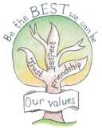
Escrick C of E Primary School Progression in Written Calculations

These are our current written calculation guidelines which were created with our teaching staff team. It outlines activities which may be used across school to support the learning of both mental and formal written calculations using the four operations ( + - x / ).
When children are taught a new concept in Maths at our school, practical and pictorial representations are used before the children are expected to explore the abstract ( written sums ); practical resources are readily available and accessed by all children in all classrooms.
Teachers ensure they teach calculations, not just discretely, but through other maths concepts such as measures and fractions and, once fluent in calculation, children are challenged through reasoning and exposed to range of worded problems and abstract representations.

Mrs C Pape / Mrs H Robinson
Maths Subject Leads
November 2021

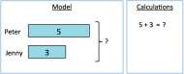
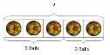
Escrick C of E Primary School Progression in Written Calculations

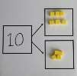
Addition

Objective and  Strategies | Concrete | Pictorial |  | Abstract
Combining two parts to make a whole: part- whole model | 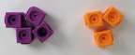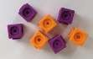  Use cubes to add | 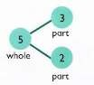 |  | 4 + 3 = 7  10= 6 + 4  Use the part-part whole diagram as shown above to move into the abstract. | 5  3
 | two numbers
 | together as a
 | group or in a bar. |  | Use pictures to add two
 |  |  | numbers together as a
 |  |  | group or in a bar model which will progress to the bars below…
 | 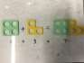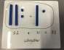 | 8 | 1
Starting at the bigger number and counting on | 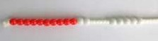  Start with the larger number on the bead string and then count on to the  smaller number 1 by 1 to find the answer | 12 + 5 = 17  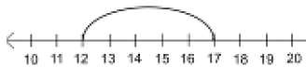 |  | 5 + 12 = 17  Place the larger number in your head and count on the smaller number to find your

 | 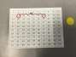  Or count on using a 100 square grid. |  | Start at the larger number on the number line and count on in ones or in one jump to find the answer. | answer.
Regrouping to make 10. | 6 + 5 = 11 |  | Use pictures or a number line. Regroup or partition the smaller number to make 10. | 7 + 4= 11  If I am at seven, how many more do I need to make 10. How many more do I add on now?
 |  | Start with the bigger number and use the smaller number to make 10. | 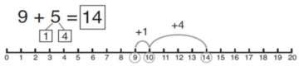
Adding three single digits | 4 + 7 + 6= 17  Put 4 and 6 together to make 10. Add  on 7.  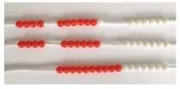 |  | + +  +  Add together three groups of objects. Draw a picture to recombine the groups to make 10. | 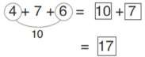  Combine the two numbers that make 10 and then add on the remainder.
 | Following on from making 10, make 10 with 2 of the digits (if possible) then add on the third digit.
 | 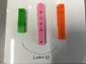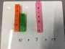
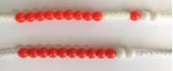
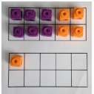
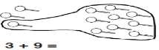

Column method- no regrouping | 24 + 15=  Add together the ones first then add the tens. Use the Base 10 blocks first before moving onto place value counters.  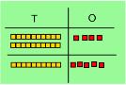  Numicon can be used her also. | After practically using the base 10 blocks and place value counters, children can draw the counters to help them to solve additions.  T O | 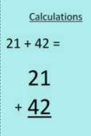
Column method- regrouping | Make both numbers on a place value grid.  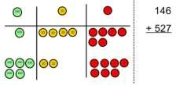  Add up the units and exchange 10 ones for one 10.  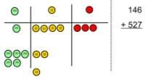  Add up the rest of the columns, exchanging the 10 counters from one column for the next place value column until every column has been added.  This can also be done with Base 10 to | Children can draw a pictoral representation of the columns and place value counters to further support their learning and understanding.  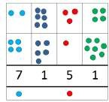  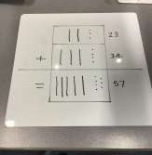  This should be shown with base 10 first. | Start by partitioning the numbers before moving on to clearly show the exchange below the addition.  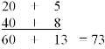  As the children move on, introduce decimals with  the same number of decimal places and different. Money can be used here.  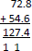
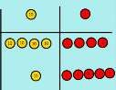
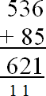

 | help children clearly see that 10 ones equal 1 ten and 10 tens equal 100.
 | This can be used to show multiplying 2+2 digit numbers also.  As children move on to decimals, money and decimal place value counters can be used to support learning. |  | 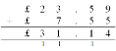  Missing number and balancing calculations should be introduced when children are able.  4087 + = 5000  7.27 + = 8
Escrick C of E Primary School Progression in Calculations

Subtraction

Objective and Strategies | Concrete | Pictorial | Abstract
Taking away  ones | Use physical objects, counters, cubes etc to show how objects can be taken away.  6 – 2 = 4  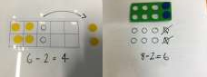 | Cross out drawn objects to show what has been taken away. | 18 -3= 15
 |  | 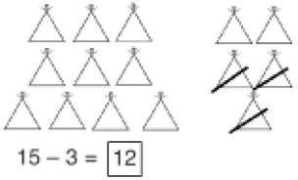 | 8 – 2 = 6
 |  | 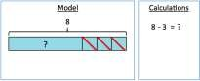

Counting back | Make the larger number in your subtraction. Move the beads along your bead string as you count backwards in ones.  13 – 4  Use counters and move them away from the group as you take them away counting backwards as you go.  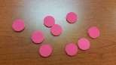 | Count back on a number line or number track  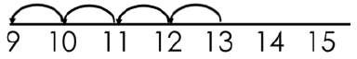  Start at the bigger number and count back the smaller number showing the jumps on the number line.  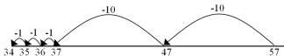  This can progress all the way to counting back using two 2 digit numbers.  Counting up from the smallest to the largest number on a blank number line may also benefit some children. |  | Put 13 in your head, count back 4. What number are you at? Use your fingers to help.
Find the difference | Compare amounts and objects to find the difference. |  | Count on to  find the difference. | Hannah has 23 sandwiches, Helen has 15 sandwiches. Find the difference between  the number of sandwiches.
Use cubes to build towers or make bars to
find the difference
 | Use basic bar models with items to find the difference | Draw bars to find  the difference between 2 numbers.
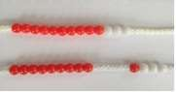
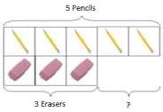
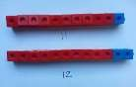
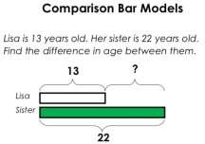
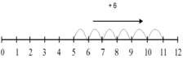

 | 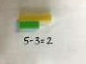
Part Part Whole Model | Link to addition- use the part whole model to help explain the inverse between addition and subtraction.  If 10 is the whole and 6 is one of the parts. What is the other part?  10 - 6 = | Use a pictorial representation of objects to show the part part whole model. | 5  10  Move to using numbers within the part whole model.
Make 10 | 14 – 9 =  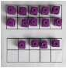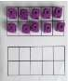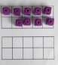  Make 14 on the ten frame. Take away the four first to make 10 and then takeaway one more so you have taken  away 5. You are left with the answer of 9. | 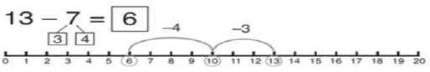  Start at 13. Take away 3 to reach 10. Then take away the remaining 4 so you have taken away 7 altogether. You have reached your answer. | 16 – 8=  How many do we take off to reach the next 10?  How many do we have left to take off?
Column method without regrouping | Use Base 10 to make the bigger number then take the smaller number away.  Numicon may be used | Draw the Base 10 or place value counters alongside the written calculation to help to show working. | 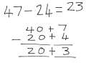
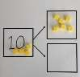
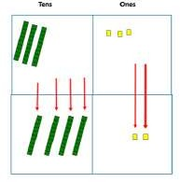
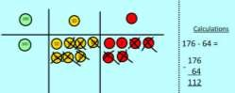
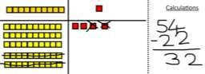

 | Show how you partition numbers to subtract.  Again make the larger number first. |  | This will lead to a clear written column subtraction.  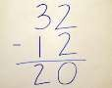
Column method with regrouping | Use Base 10 to start with before moving on to place value counters. Start with one exchange before moving onto subtractions with 2 exchanges.  Make the larger number with the place value counters  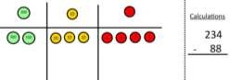  Start with the ones, can I take away 8 from 4 easily? I need to exchange one of my tens for ten ones.  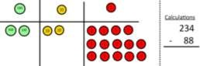 | Draw the counters onto a place value grid and show what you have taken away by crossing the counters out as well as clearly showing the exchanges you make.  When confident, children can find their own way to record the exchange/regrouping.  Just writing the numbers as shown here shows that the child understands the method  and knows when to exchange/regroup. | 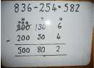  Children can start their formal written method by partitioning the number into clear place value columns.  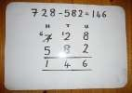  Moving forward the children use a more compact method.
 | Now I can subtract my ones.  Now look at the tens, can I take away 8 tens easily? I need to exchange one hundred for ten tens. |  | This will lead to an understanding of subtracting any number including decimals.
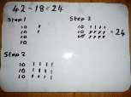
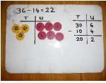
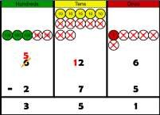

 | 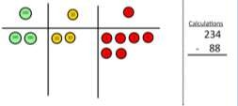 |  | 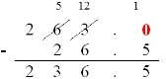
 | 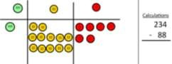  Now I can take away eight tens and complete my subtraction |  | Missing number and balancing calculations should be introduced when children are able.  5087 - = 3000  9.26 + = 8
 | 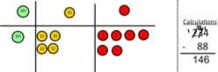
 | Show children how the concrete method links to the written method alongside your working. Cross out the numbers when exchanging and show where we write our new amount.

Escrick C of E Primary School Progression in Calculations

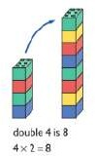
Multiplication

Objective and  Strategies | Concrete | Pictorial | Abstract
Doubling | Use practical activities to show how to  double a number.  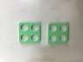 | Draw pictures to show how to double a number.  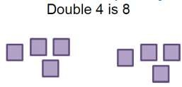 | 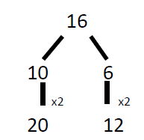  Partition a number and then double each part before recombining it back together. Multiplication could also be shown as repeated addition here ( 10  + 10 and 6 + 6 )
Counting in multiples | 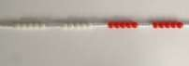  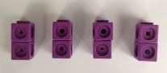  Count in multiples supported by concrete objects in equal groups. | 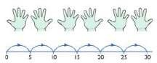  Use a number line or pictures to continue support in counting in multiples. | Count in multiples of a number aloud.  Write sequences with multiples of numbers.  2, 4, 6, 8, 10  5, 10, 15, 20, 25 , 30  Challenge comes from counting on from different numbers.

 | 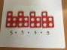  We have numicon number lines in school to count shapes along. This can also be counted with cuisenaire rods. | 4 4 4 4 4 | Once x tables are fluent, they can be used to calculate with known facts, find factor pairs, primes, squares etc.  e.g. 200 x 3 = 600, 600 ÷ 3 =  200  7 × 9 = 63 so one-ninth of 63 is 7 and one seventh  of 63 is 9
Repeated addition | 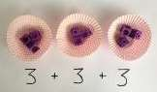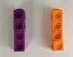  Use different objects to add equal groups. | 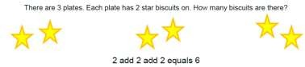  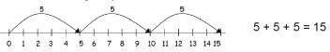 | Write addition sentences to describe objects and pictures.  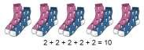

Arrays- showing commutative multiplication | Create arrays using counters/ cubes to show multiplication sentences.  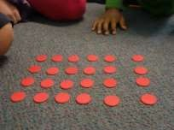  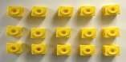 | Draw arrays in different rotations to find commutative multiplication sentences.  Link arrays to area of rectangles. | Use an array to write multiplication sentences and reinforce repeated addition.  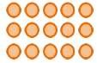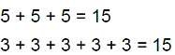
Column multiplication | Children can continue to be supported by place value counters at the stage of multiplication.  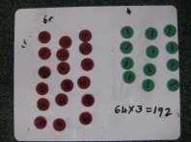  It is important at this stage that they always multiply the ones first and note down their answer followed by the tens which they note below. | Bar modelling and number lines can support learners when solving problems with multiplication alongside the formal written methods.  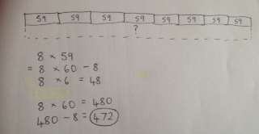  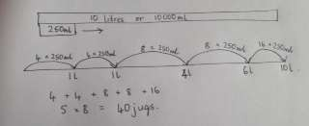 | Start with long multiplication, reminding the children about lining up their numbers clearly in columns.  If it helps, children can write out what they are solving next to their answer.  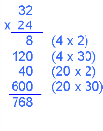
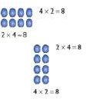
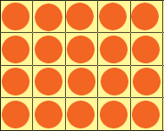

This moves to the more compact

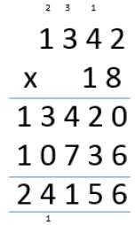
method.

Tens and ones can be colour coded to support
children if necessary.
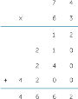

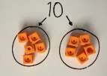

Escrick C of E Primary School Progression in Calculations

Division

Objective and Strategies | Concrete | Pictorial | Abstract
Sharing objects into groups | 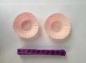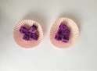  I have 10 cubes, can you share them equally in 2 groups? | Children use pictures or shapes to share quantities.  8 ÷ 2 = 4 | Share 9 buns between three people.  9 ÷ 3 = 3
 | 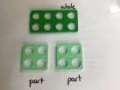 + with Numicon.
Division as grouping | Divide quantities into equal groups. Use cubes, counters, objects or place value counters to aid understanding.  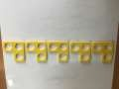 | Use a number line to show jumps in groups. The number of jumps equals the number of groups.  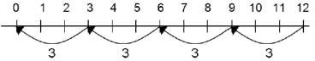  Think of the bar as a whole. Split it into the number of groups you are dividing by and work out how many would be within each group. | 28 ÷ 7 = 4  Divide 28 into 7 groups. How many are in each group?  As children move through KS2, use similar representations to recognise fraction and decimal equivalents of one-

 | 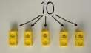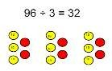 | 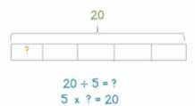 | half,  quarters, tenths and hundredths  e.g. 3 tenths is 0.3 and 3 hundredths is 0.03
Division within arrays | Link division to multiplication by creating an array and thinking about the  number sentences that can be created. | 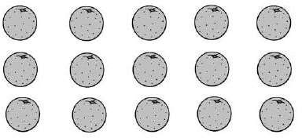 | Find the inverse of multiplication and division sentences by creating four linking number sentences.  7 x 4 = 28  4 x 7 = 28  28 ÷ 7 = 4  28 ÷ 4 = 7
 | Eg 15 ÷ 3 = 5 5 x 3 = 15  15 ÷ 5 = 3 3 x 5 = 15 | Draw an array and use lines to split the array into groups to make multiplication and division sentences.
Division with a remainder | 14 ÷ 3 =  Divide objects between groups and see how much is left over | Jump forward in equal jumps on a number line then see how many more you need to jump to find a remainder.  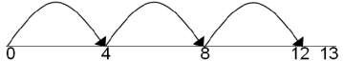  Draw dots and group them to divide an amount and  clearly show a | Complete written divisions and show the remainder using r.  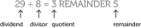
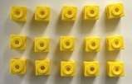
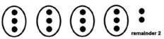
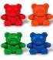

 |  | remainder.
Short division | 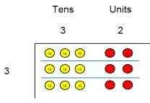  Use place value counters to divide using the bus stop method alongside  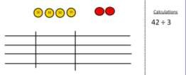  42 ÷ 3=  Start with the biggest place value, we are sharing 40 into three groups. We can put 1 ten in each group and we have 1 ten left over. | Students can continue to use drawn diagrams with dots or circles to help them divide numbers into equal groups.  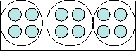  Encourage them to move towards counting in multiples to divide more efficiently. | Begin with divisions that divide equally with no remainder.  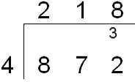  Move onto divisions with a remainder.  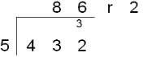  Finally move into decimal places to divide the total accurately.  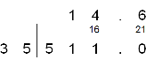

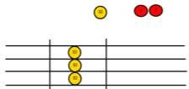

We exchange this ten for ten ones and then share the ones equally among the groups.

We look how much in 1 group so the answer is 14.
