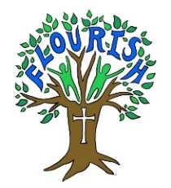Together in Worship
Themes and Resources – Autumn 2022
The colours below are used to support expression of Anglican distinctiveness and tradition. They are linked to the Christian calendar and depicted by colours, each season has a colour and change with the pattern of Worship as shown below.
Colour | Season Mood | When used
White | Joy and Rejoice | Christmas, Easter, Epiphany, Ascension and All Saints
Purple | Thinking deeply and waiting | Advent  Lent
Green | A time to grow | Ordinary days ( not celebrations)
Red | Sad times and certain  Joyful times | Ordinary days ( not celebrations)

Themes 2022
Autumn 2022 | Thankfulness and Generosity  Harvest  Compassion  Advent  Christmas
Spring 2023 | Courage  Trust and Respect  Easter
Summer 2023 | Friendship  Forgiveness
Autumn 2023 | Thankfulness  Harvest  Creation and Trust  Advent  Christmas
Spring 2024 | Hope and Courage  Lent  Easter  Service and Humility
Summer 2024 | Justice and Peace  Wisdom and Perseverance

