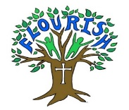

Year 1 Long Term Plan*Highlighted topics state the topic driver for the whole term

English  TEXT FOCUS | Focus Education: Dogger  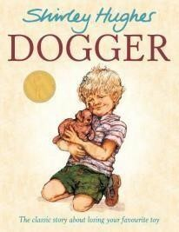 | Focus Education: Naughty Bus  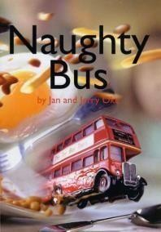 | Focus Education: Rabbit Problem  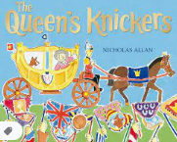 | 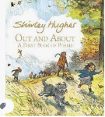 | 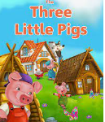 | 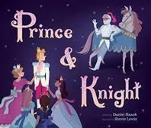
Text types/genre  And number of weeks.  F – fiction  NF – non fiction  P - poetry | Stories from familiar settings (F) (4 weeks)  Labels, lists and captions (NF) 2 weeks | Stories from familiar settings 2 (F) (3 weeks)  Info texts (NF) (2 weeks)  Poem – senses (1 week) | Stories about fantasy worlds (F) (4 weeks)  Instructions (NF) (3 weeks) | Recounts NF (2 weeks)  Playscripts (F or NF) (3 weeks)  Poem – description and alliteration (1 week) | Traditional tales (F) (4 weeks)  Info texts – leaflets (NF) (2 weeks) | Stories (topic of choice) TRANSITION UNIT (F) (4 weeks)  Recount (F and NF) (3 weeks)
SPAG content | - Simple sentence with a noun/proper noun  - Simple sentence with a pronoun  - Full stops  - Simple past tense  - First person | - Orally use simple coordinating conjunctions  - Compound sentences using and  - Connectives of sequence  - Subject verb agreement  - Adjectives | - Capital letters for people and places  - Capital letter for I  - Start sentences with capital letters  - Use capital letters for days of the week  - Separate words with spaces | - Regular plurals adding s or es  - Suffixes of verbs ending in ed or ing  - Prefix un to create antonyms  - Determiners  - Orally devise alliteration | - Adverbs of manner ending in ly  - Prepositions  - Similes  - Question marks | - Comparative and superlative adjectives – er, est to adjectives  - Choose specific nouns  - Noun phrases – adjective+noun  - Use exclamation marks
Handwriting and phonics/spelling | - Handwriting – following Little Wandle letter formation.  - Phonics/Spellings – Little Wandle revised letters and sounds programme.  - In reception and Y1, children follow the progression within Little Wandle Letters and Sounds Revised programme. Phonics is taught daily (4 sounds a week, 1 sound a day) and there is a review session on a Friday.  - By the end of reception, children will have been taught up to the end of phase 4.  - By the end of year 1, children will have been taught up to the end of phase 5.  - Year 1 lessons are 30 minutes long.  - Keep up catch up groups for target groups and spellings containing taught sounds sent home weekly for all children as homework.
Maths | Composition of Numbers 0-5  Composition of Numbers 6-10  Comparison of Quantities and Measures | Introducing Whole and Parts  Shape  Additive Structures | Addition and Subtraction within 10  Composition of Number 11-19  Time | Composition of number 20-100  Measure- Length, Height and Volume | Counting, Unitising and Coins.  (Counting in 2s, 5s and 10s).  Fractions  Position and Direction. |  | Measurement: Time  Revisit Number and Place Value within 100.
Science | Animals Including Humans  How are Humans like tigers?  Text: Tiger | Seasonal change focus – How can we tell it’s Autumn?  Animals cont.  Jane Goodall/David Attenborough | Seasonal Changes  What type of weather do we have in each season?  Focus Education: Rabbit Problem | Where do plants come from?  Which birds and plants would little Red Riding Hood find in our area?  Visit to a local woodland/river | Materials  What do aliens think of earth? | Seasonal Change Recap  I know it’s summer because…. Inc all seasons recap – link to maths - months of the year which month is in which season.
 |  |  |  |  | Focus Education: Beegu

History | What was life like for our grandparents? Focus Education: Dogger | Book idea: Family tree History/PSHE Book See AD recommended text list | Life of Queen Elizabeth 2nd and other cultural/historic icons Mary Anning
Geography |  | York/Hull – UK cities  Focus Education: Naughty Bus |  | Further study: UK countries, counties and capitals | Why can't a Meerkat live on the North Pole?  -  Continents and Oceans | Continuation over the full summer term.  Joint trip to the coast with year 2
 |  |  |  |  | Focus Education: Lost and Found
Design and |  | Make a moving vehicle | Design and make a | Bake/taste links to UK | Recycling. Using scrap
Technology |  | using axles and | crown that is | countries | materials for traditional
 |  | wheels/Design a world | aesthetically pleasing |  | tale houses.
for Naughty bus to
travel round.
Art and Design | Still life Drawing toys and experimenting with different textures and  shading.  Know how to use pencils to create lines of different thickness in drawings. | Model vehicles Exploring materials – know how to cut, roll and coil materials.  BONUS: Paintings of vehicles – buses, cars, taxis. | Portraits  Final piece – portrait of the Queen.  Know how to show how people feel in paintings and drawings.  Artist study: Picasso, Andy Warhol.  To ask questions about a piece of art. | Painting/oil pastel Sunflowers by Van Gogh – know how to create moods in art work. Link to silhouette.  Describe what can be seen and give an opinion about the work of an artist.  Know the names of the primary and secondary colours. | Exploring texture and printing - know how to create a repeating pattern in print.  Textures in nature and manmade materials – make a simple printing block and produce repeating patterns.  Counting in 2s 5s 10s | Artist study:  Turner – watercolour paintings of the ocean.  know how to create moods in art work

Physical Education | Fundamentals  Forest School | Fitness  Forest School | Gymnastics  Forest School | Invasion Games  Forest School | Swimming  Forest School | Athletics  Forest School
Computing | Technology around us | Digital painting | Moving a robot | Grouping data | Digital writing | Programming animations
RE | 1.7 What does it mean to belong to a faith community? | UC 1.1 What do Christians believe God is like? | 1.3 Who is Jewish and what do they believe? | 1.3 Who is Jewish and what do they believe? | UC 1.2 Who do Christians say made the world? | 1.7How should we care for the world and for  others, and why does it matter? (C, J, NR)
PSHE | Jigsaw - Being Me In My  World | Jigsaw - Celebrating  Difference | Jigsaw - Dreams and  Goals | Jigsaw - Healthy Me | Jigsaw - Relationships | Jigsaw - Changing Me
Music | Hey you!  (Old School Hip-Hop) | Rhythm in the way we walk & Banana Rap  (Reggae) | In the Groove  (Blues, Baroque, Latin, folk) | Round and Round  (Bossa Nova) | Your Imagination  (Pop) | Reflect, Rewind & Replay  (Classical)
Spanish | Salutations |  | Nursery Rhymes |  | Colours  Numbers

Year 2 Long Term Plan *Highlighted topics state the topic driver for the whole term

 | Aut 1 |  | Aut 2 |  | Spr 1 |  | Spr 2 |  | Sum 1 | Sum 2
English | Focus Education: |  | Focus Education: |  | Focus Education: |  | Focus Education: Rosa |  | Focus Education: Little Evie in | Recount of trip
 | Traction Man |  | Major Glad, Major |  | Wild |  | Parks |  | the Wild Wood
 | 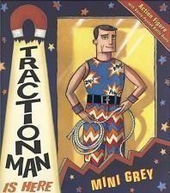 |  | Dizzy  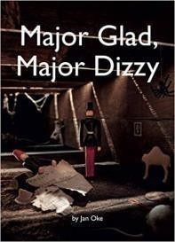 |  | 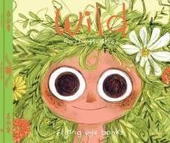 |  | 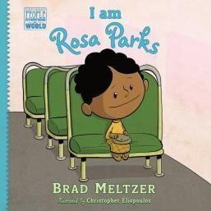 |  | 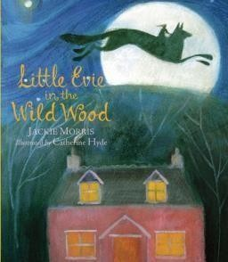
Text types/genre  And number of weeks.  F – fiction  NF – non fiction  P - poetry | Stories with familiar settings (F) (3/4 weeks)  Information texts (NF) (2 weeks)  Poems (2 weeks) |  | Stories with familiar settings (F) (3 weeks)  Non-chronological reports (3 weeks)  Diaries/recount (1 week) |  | Different stories by the same author (F) (4 weeks) – Emily Hughes  Explanation texts (NF) (3 weeks)  Poems – Really looking (2 weeks) |  | Traditional stories (F) (2 weeks)  Non-chronological reports (NF) (3 weeks)  Poems part 2 (2 weeks) |  | Extended stories (F) (3 weeks)  Diaries and recounts (NF) (2 weeks)  Poems – Silly stuff (2 weeks) | Stories by significant authors (F) (3 weeks)  Transition unit – (Non-Fiction text that could be improved – instructions, explanations or non-chron report.)  3 weeks
SPAG content | - Suffixes – ness, er  - Compound nouns  - Suffixes – ful and less  - Comparative and superlatives using er and est suffix |  | - Adverbs using ly suffix  - Coordinating conjunctions – compound sentences  - Subordinate conjunctions  - Expanded noun phrases  - Statement – simple sentences |  | - Questions  - Commands  - Exclamations  - Simple present tense  - Present continuous tense |  | - Simple past tense, adding ed  - Past progressive  - Commas in lists  - Apostrophes for omissions  - Spoken words into commas |  | - Move from generic nouns to specific nouns  - Temporal connectives  - First, second and third person  - Onomatopoeia  - Alliteration | - Similes  - Prepositional phrase  - Determiners/ generalisers
Handwriting and phonics/spelling | - Handwriting – following penpals letter formation (curly caterpillars, etc) and scope and sequence, Year 2 joins. Daily sessions and opportunities for assessment.  - Phonics/spelling - Using Little Wandle assessment, identifying areas needed for keep up catch up. Daily phonics sessions. Y2 NNS used for spelling patterns and content. Weekly lists sent home to learn for homework and in school weekly spellings tests.
Maths | Addition and Subtraction Bridging 10.  Subtraction as a difference. | Addition 2 digit and 2 digit.  Subtraction 2 digit and 2 digit.  Measure- Money. |  | Multiplication – representing equal groups.  Times tables- groups of 2 and commutativity.  Commutativity, doubling and Halving. |  | Structures- quotative and partitive division.  Statistics.  Fractions |  | Measure Length and Height.  Geometry- Position and Direction |  |  | Measurement – Time (cont)  Measurement- Mass and Capacity
 | Addition and Subtraction 2 digit and 3 digit.  Addition and subtraction 2digit and multiples of 10.  Shape |  |  | Measures- Temperature. |  | Shape and their properties. |  | Measurement- Time |  |  | NCETM Catch up / Addition and  Subtraction with measures
Science | Materials | Materials Continued.  Famous Scientist Focus |  | Living Things and Habitats |  | Plants |  | Animals Including Humans  How can we stay healthy? |  |  | Animals Including Humans  How can we stay healthy?
 | What would traction man use to build our school?  Focus Education: Traction Man |  |  | Why would a dinosaur not make a good pet? |  | How are new plants made?  Focus Education: Little Evie in the wild wood

History |  | What was life like for The Victorians? Focus Education:  MajorGlad, MajorDizzy |  | How have people like Rosa Parks helped make the world a better place? | Why do we like to be beside the seaside?
Geography | Victorian York/ Map work/ariel photographs |  | Where would you like to live, The UK or Africa?  Focus Education: Lila and the secret of rain |  | Oh, I do like to be beside the seaside!  What is life like beside the seaside? | Seaside trip and possible links to the Victorians
Design and Technology | Design and build a school. Cutting using junior hacksaw | Making Victorian Toys. Handrill for making quoits game | Constructing an African house using hatching. | Clay work. Make a Rosa Parks commemorative Coin using appropriate tools. | Making a beach hut using wood. Who has the strongest hut? | Making a strong, sturdy bridge to cross water or Piers.  Brighton Pier
 |  |  | African foods
Art and Design | Exploring materials | Victorians | African Art | Floral art/rainforests | Clay – sculpture. | Photo editing/digital
 | Use different | Artist: L.S.Lowry | Explore textures and | Artists: Henri Rousseau | Practise with play | art
 | grades of pencil, | street scenes. | patterns in nature. | – rainforests. | doh/plasticine with sculpting | Editing seaside photos
 | pastels, oil pastels, | Art inspired by an | Know how to create a | William Morris – Floral | challenges. | with effects.
 | paints and explore | artist. | printed piece of art | art. | Know how to make a clay pot | Beach hut digital art
 | the different | To mix paint to | by pressing, rolling, | Art inspired by an artist | and Know how to join two clay | using shape tools and
 | effects created. | create all the | rubbing and | To choose and use | finger pots together. | filling with paint.
 | Artist: Lichtenstein | secondary colours | stamping. | three different grades | Artist: Barbara Hepworth – | Duplicate tool.
 | superhero art (Link | and create tones |  | of pencil when drawing | lived and worked near the | Know how to use
 | to Traction Man). | and tints. |  | Explore using pencil, | coast, can they see her | different effects within
 |  |  |  | pastel and paint to | inspiration? | an IT paint package
 |  |  |  | create different effects. | Could make a seaside themed
 |  |  |  |  | pot/mug/vase.
Physical Education | Yoga  Forest School | Ball skills  Forest School | Tennis – Net and Wall  Forest School | Gymnastics  Forest School | Fitness  Forest School | Swimming  Forest School
Computing | Information and  technology around us | Digital photography | Robot algorithms | Pictograms | Making music | Programming quizzes

RE | 1.2 Who is a Muslim and what do they believe?  Part 1 | UC 1.3 Why does Christmas matter to Christians? | 1.2 Who is a Muslim and what do they believe? Part 2 | UC 1.5 Why does Easter matter to Christians? | UC 1.4 What is the ‘good news’ Christians believe Jesus brings? | 1.5 What makes some places sacred? (C,M)
PSHE | Jigsaw - Being Me In My World | Jigsaw -  Celebrating Difference | Jigsaw - Dreams and Goals | Jigsaw - Healthy Me | Jigsaw - Relationships | Jigsaw - Changing Me
Music | Hands, Feet, Heart (Afropop, South African) | Ho, Ho, Ho (Rapping Song) | I Wanna In a Band (Rock) | Zootime  (Reggae) | Friendship Song  (Pop) | Reflect, Rewind and Replay  (Classical)
Spanish | Revise Salutations,  Numbers and Colours |  | Days of the Week |  | Shapes

Year 3 Long Term Plan *Highlighted topics state the topic driver for the whole term

 | Aut 1 | Aut 2 | Spr 1 | Spr 2 | Sum 1 | Sum 2
English | Focus Education:  Science  Light and dark  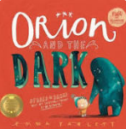 | 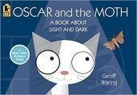  Light and Dark | Focus Education: The Night  Gardener  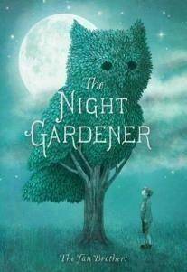 | Focus Education: The Night Gardener  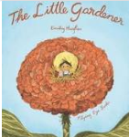 | Focus Education: Street Beneath my Feet  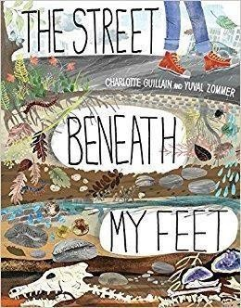 | 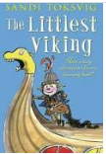  Vikings
Text types/genre  And number of weeks.  F – fiction  NF – non fiction  P - poetry | F: Adventure stories (3 weeks)  NF: Reports/information text (3 weeks) | F: Stories with familiar settings  (3 weeks)  NF: instructions (2 weeks)  P – poems to perform (2 weeks) | F: Adventure and mystery (4 weeks)  NF: Information texts (2 or 3 weeks) | F: Authors and letters (3 weeks)  NF: Reports (2 weeks)  P: Shape poems and calligrams (1 – 2 weeks) | F: Myths and legends  (4 weeks)  NF: Information text and glossaries (2 - 3 weeks) | F: Dialogue and plays (3 weeks)  NF: TRANSITION unit – biography or persuasion.  P: language play (2 weeks)
SPAG content | - Speech Marks  - Adverbs  - Prepositions  - Expanded noun phrases  - Suffixes  - Homophones | - Prepositions  - Past perfect  - Homophones  - Contractions  - Synonyms for adjectives | - Conjunctions  - Complex sentences  - Verbs – past tense and irregular verbs  - Synonyms for verbs | - Prefixes (auto, anti, super, under)  - Exaggerated language  - Pronouns  - Possessive pronouns and apostrophes | - Specific/technical vocab (linked to myths).  - Phrase and a clause  - Plurals  - A or an  - Homophones  - Time conjunctions | - Conjunctions – complex and time  - Adverbial phrase – comma after  - Persuasion – power of three  - Speech marks  - Verb synonyms: Said, replied, asked.
Handwriting and phonics/spelling | - Handwriting: Following penpals scope and sequence for Year 3 joins (and catch up coverage of letter formation/fine motor skills and Year 2 joins if needed). Daily handwriting sessions and opportunities for assessed pieces.  - Phonics/Spelling: Children assessed for reading ability and phonics sounds and phonics taught through reading sessions and one to one with readers. Flashcards, words, phonics games and activities used for consolidation and practice.  - NNS Year 2 words for catch up group. NNS Year 3 words – daily spelling practice sessions, weekly spellings sent home, in school tests every Friday.
Maths | Number and Place Value, Addition and Subtraction | A and S contd. Measures: Money Measures: Length (Science) and Perimeter | Multiplication and Division Fractions  Apply measures knowledge to design a garden/ fractions | Fractions contd. Statistics (Science) | Measurement: Time, Mass and Capacity  York through time A day in York in Viking  times | Geometry: Properties of Shapes  Year review and application
Science | Light and Dark | Forces  What affects magnetic strength? | Plants (Spring) | Visit to Harlow Carr -
 | Why can you see your reflection in the mirror but not the floor? |  |  | Harrogate | Rocks and Soils | Animals Including Humans  Why do we have a skeleton?
 |  |  | What makes plants and
 |  |  | flowers grow and |  | What is the Earth made from?
 | Focus Education:  Orion and the |  | flourish?
 | dark

History | Who were The Normans?  Local history |  |  |  | Vikings | Vikings – Local history
Geography | Isn’t Britain Great?  UK Locational Knowledge |  | Amazing Places.  European Borders and Capitals |  | York - How did the Vikings use York and how has it changed?
Design and Technology | Shadow Puppets  using appropriate materials. | Making a pulley system | European foods from  different countries and cultures. | Design a structure or  sculpture for Harlow Carr. | Using animations. Design  a set which depicts the Viking invasion of York. | Viking Longboats and the mechanics.
Art and Design | Still life |  | Flower paintings know how to create a background using a wash.  Know how to use a range of brushes to create different effects in painting.  Artists: Georgia O’Keefe – flower watercolours.  Other artists for comparison (comparing artists objectives).  Frida Kahlo. Claude Monet. | Sculpture | Portraits and angry | Animal art
 | (Can be extended to full term) |  |  | Clay sculpture. | Vikings | To recognise when art is
 | Introduction to sketchbooks. |  |  |  |  | from different cultures.
 | Know how to use sketches to produce |  |  | Progression from | Know how to show facial | To research and explore
 | a final piece of art. |  |  | making a pot, to | expressions in art. | how animals are
 | Focus: light and dark and the use of |  |  | making a hollow |  | portrayed in art over
 | shading to create shadows and 3d |  |  | sculpture. | Use sketchbooks to | different time periods
 | objects. |  |  |  | explore portrait drawing, | and by different artists.
 | Artist: M. C. Escher. |  |  | Yorkshire sculpture | focusing on different | Artists: cave paintings,
 | Technique: chiaroscuros – artist, |  |  | Park – online website | features and expressions. | Henri Rousseau tiger,
 | Caravaggio – 3d fruit. |  |  | galleries. | Final piece: Viking | Damien Hirst animal
 | Know how to use different grades of |  |  |  | portrait showing | sculpture *controversial,
 | pencil to shade and to show different |  |  |  | anger/war face. | Pablo Picasso, Yago
 | tones and textures. |  |  |  |  | Partal – animals in
human clothes. Digital
art opportunity.
Physical Education | Swimming Forest School | Dance Forest School | Ball Skills - Tag Rugby Forest School | Gymnastics Forest School | Tennis Forest School | Athletics Forest School

Computing | Connecting computers Identifying that digital devices have inputs, processes, and outputs, and how devices can be  connected to make networks. | Stop-frame animation Capturing and editing digital still images to produce a stop- frame animation that tells a story. | Sequencing sounds Creating sequences in a block-based programming language to make music. | Branching databases Building and using branching databases to group objects using yes/no questions. | Desktop publishing Creating documents by modifying text, images, and page layouts for a specified purpose | Events and actions in programs  Writing algorithms and programs that use a range of events to trigger sequences of actions.
RE | UC L2.1 What do Christians learn from the Creation story? UC L2.2 What is it like for someone to follow God? | UC L2.1 What do Christians learn from the Creation story? UC L2.2 What is it like for someone to follow God? | L2.4 Why do people pray? (M/C) | L2.5 Why are festivals important to religious communities (J/M) | L2.4 What kind of world did Jesus want? | L2.9 What can we learn from religions about deciding what is right and wrong? (C, M/J, NR)
PSHE | Jigsaw - Being Me In My World | Jigsaw -  Celebrating Difference | Jigsaw - Dreams and Goals | Jigsaw - Healthy Me | Jigsaw - Relationships | Jigsaw - Changing Me
Music | Trumpets  Focus pieces: Boozey Brass Stage 1, Suo Gan notes | Trumpets  Focus pieces: Suo Gan, Jingle Bells | Trumpets  Focus pieces: Romance, Blue Tulip | Trumpets  Focus pieces: Blue Tulip, We Will Rock You | Trumpets  Focus pieces: Queen Medley, My Own Rock Band | Trumpets  Focus pieces: Prep for summer concert, When the Saints
Spanish | Revise I’m Learning Spanish – introductory unit 2021 / Salutations  Revise Numbers and Colours  Phonics Lesson 1 | Revise Days of the Week  Teach Months of the Year | Fruits |  | Instruments ( Music ) | Animals

Year 4 Long Term Plan *Highlighted topics state the topic driver for the whole term

 | Aut 1 | Aut 2 | Spr 1 | Spr 2 | Sum 1 | Sum 2
English  Specific Text Types in bold to be taught | Focus Education: The Lorax  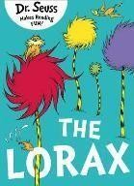 | Possible Story  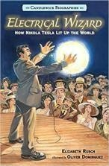 | Focus Education: The Promise  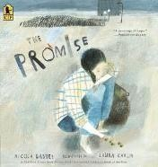 | 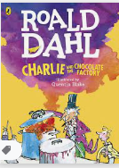  Water cycle/states of matter | Focus Education: The Incredible Book Eating Boy  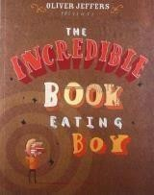 | Possible Story The Littlest Viking  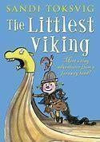
Text types/genre  And number of weeks.  F – fiction  NF – non fiction  P - poetry | Persuasive letters (NF) (4 weeks)  Stories with Historic settings (F) (3 weeks) | Information texts – Biographies (NF) (3 weeks)  Instructions (NF) (3 weeks)  Poetry - Creating images (P) (1 week) | Stories from other cultures (F) (3 weeks)  Recounts/ news reports (NF) (3 weeks) | Stories set in imaginary worlds (F) (3 weeks)  Explanations – The Water Cycle (NF) (3 weeks) | Stories that raise issues/dilemmas (F) (2 weeks)  Informal letters (NF) (2 weeks)  Creative poetry (P) (1 week)  Poetry – Exploring form (P) (1 week) | Playscripts (F) (3 weeks)  Transition unit – discussion text/argument (NF)
SPAG content | - Informal and formal language  - Plural nouns  - Homophones  - Fronted adverbials  - Expanded noun phrases  - Using a dictionary and thesaurus  - Repetition to persuade | - Possessive pronouns  - Prefixes: in, il, im, re, sub, inter, auto  - Possessive apostrophes (singular and plural)  - Specific determiners  - Verbs – past perfect continuous | - Prepositions  - Verbs ending in y changes to ies  - Suffixes: sion, ous, cian, ly  - Write words spelt ch – scheme, chemist, chef  - Connectives  - Inverted commas | - Verbs – modal verbs, could should would  - Technical language  - Synonyms  - Powerful verbs  - Pronouns for cohesion | - Compound nouns  - Comparative and superlative adjectives  - Proper nouns  - Compound sentences  - Starting a sentence with ing – Flying through the air, he… | - Drop in clause with ing as an embedded clause  - A sentence with 3 actions  - Adjectives ending in ed  Recap/revision
Handwriting and phonics/spelling | - Handwriting: Following penpals scope and sequence for Year 4 joins. 3 or 4 sessions per week plus opportunities for assessed pieces.  - Phonics/Spellings – NNS Year 4. Weekly spelling lists sent home for homework and in school spelling tests every Friday.
Maths | Number and Place | Measurement: | M and D contd. | Fractions | Decimals | Geometry: Position and
 | Value, Addition and | Length and | Measurement: |  | Measurement: Money and | Direction
 | Subtraction | Perimeter | Area |  | Time | Statistics
 |  | (rainforests – Y3 | Geometry |  |  | Year review and
 |  | metres) | (Mayans) |  | Nutrition content of foods | application
 |  | Multiplication and  Division |  |  | and costing a shopping bill
Science | Sound  How is sound produced?  Focus Education: The Pied Piper of Hamelin | Electricity  What are electrical circuits and how do they work? | Living Things and habitats  How do animals adapt to their environments? | States of matter  How do states of matter impact the water cycle? | Animals including Humans  What journey does food go on?  Focus Education: The Incredible Book Eating Boy
History |  | Remembrance Day | Who were The Mayans? |  | Anglo Saxons and the struggle for England with the Vikings 450AD | Trip to Viking Centre with year 3

Geography | Journey into the rainforest.  Biomes Time Zones  Latitude/ Longitude and Hemispheres- Lorax | Focus unit 900AD  – rainforest | South America Focus  Or The Wild West  (Regions, key physical and human characteristics, countries, and major cities) |  |  | European Regional Study - Locate the countries of Europe, including Russia. Look at the environmental regions of Europe.
Design and | Design and create a | Create a product | Making a strong, | Forest School D & T: | Make a working digestive | Building Famous
Technology | model of a biome. | with an electrical | sturdy structure | chopping and grating | system model. | Landmarks.
 |  | circuit. | like a Mayan | vegetables for soup.
Temple thinking
about detailing.
Art and Design | Rainforest art – The Spirit of the Rainforest (See Eden Project site) Artist: John Dyer Colourful paintings with spiritual and cultural significance.  Artist: Nixiwaka Yawanawá | Optical illusions – Artist: M.C.Escher.  Know how to use line, tone, shape and colour to represent figures and forms in movement and know how to show reflections | Portraits  Emotion and feeling  Know how to show facial expressions and body language in sketches and paintings. | Mayan prints Create a print inspired by the Mayan murals – using overlapping patterns in different colours.  Know how to print onto different materials using at least four colours. | Fruit and Veg – Still life  Artist: Arcimboldo Experiment with the styles used by other artists. | Clay sculpture  Model houses – begin with making a hollow pot, combining two together, creating texture and detail. (Can be made into tealight holders).
Physical Education | Swimming  Forest School | Hockey  Forest School | Netball  Forest School | OAA - orienteering  Forest School | Cricket  Forest School | Dodgeball  Forest School

Computing | The Internet | Audio editing | Repetition in | Data logging | Photo editing | Repetition in games
 | Recognising the | Capturing and | shapes | Recognising how and | Manipulating digital images, | Using a block-based
 | internet as a  network of | editing audio to  produce a | Using a text-  based | why data is collected  over time, before | and reflecting on the impact  of changes and whether the | programming language to  explore count-controlled
 | networks including  the WWW, and | podcast, ensuring  that copyright is | programming  language to | using data loggers to  carry out an | required purpose is fulfilled. | and infinite loops when  creating a game.
 | why we should | considered. | explore count- | investigation.
 | evaluate online content. |  | controlled loops  when drawing  shapes.
RE | UC L2.3 What is the ‘Trinity’ and why is it important for Christians | L2.8 What does it mean to be Hindu in Britain today? | L2.8 What does it mean to be Hindu in Britain today? | UC L2.5 Why do Christians call the day Jesus died ‘Good Friday’ | UC L2.6 For Christians, when Jesus left, what was the impact of Pentecost? | L2.6 Why do some people think that life is a journey and what significant  experiences mark this? (C, H, NR)
PSHE | Jigsaw - Being Me In My World | Jigsaw -  Celebrating Difference | Jigsaw - Dreams and Goals | Jigsaw - Healthy Me | Jigsaw - Relationships | Jigsaw - Changing Me
Music | Mamma Mia (Pop) | Glockenspiel Stage 2 | Stop! (Grime) | Lean on Me (Gospel) | Blackbird (The Beatles / Pop) | Reflect, Rewind and Replay  (Classical)
Spanish | Presenting Myself  Revise Y3 through lessons  Phonics Lesson 1 + 2 | Weather | Families |  | Fruit ( revise ) and Vegetables | My home or In class

Year 5 Long Term Plan *Highlighted topics state the topic driver for the whole term

 | Aut 1 | Aut 2 | Spr 1 | Spr 2 | Sum 1 | Sum 2
English  Specific Text Types in bold to be taught | Focus Education: The Journey of Iliona  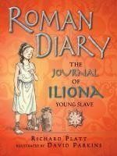 | 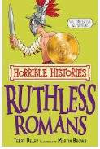 | Focus Education: Cosmic  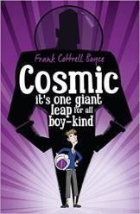 | Focus Education: The Man who Walked between the Towers  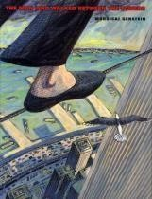 | Focus Education: Nowhere Emporium  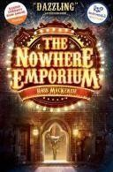 | Focus Education: Nowhere Emporium
Text types/genre  And number of weeks.  F – fiction  NF – non fiction  P - poetry | Narratives by a significant author (F) (4 weeks)  Recounts (4 weeks) | Instructions NF (3 weeks)  Word Play Poems (2 weeks)  Stories from other cultures (F) (2 weeks) | Narratives (F) (2 weeks)  Persuasion (4 weeks) | The Highwayman (P) (2 weeks)  News reports (NF) (2 weeks) | Playscripts (F) (3 weeks)  Explanation text (NF) 3 weeks) | Extended stories (F) (3 weeks)  Transition/info text (NF)
SPAG content | - Prefixes and suffixes – nouns into verbs - ate, ise, ily + cious cial ant ent ance ence  - Silent letters  - Homophones  - Fronted adverbial and prepositional phrases  - Use a dictionary and thesaurus | - Brackets for parenthesis  - Dashes for parenthesis  - Commas for parenthesis  - Relative pronouns  - Relative clauses  - Metaphors  - Personification  Onomatopoeia | - Developing technical language  - Start a complex sentence with a subordinate clause  - Connectives to build cohesion  - Rhetorical questions  - Expanded –ed clause: Frightened of the dark, Tom hid under the bed.  - Formal voice | - Speech in inverted commas  - Degrees of possibility – modals and adverbs | - Moving parts of sentences round for effect  - Future tense verbs  - Colons for play scripts and to start a list  - Hyphens  - Determiners | - AfL revision  - Y5/6 words focus – further coverage  - Active and passive voice
Handwriting and phonics/spelling | - Handwriting – following penpals scope and sequence joins for Year 5. 2 or 3 sessions weekly and opportunities for assessed pieces.  - Spelling – NNS spelling Year 5. 3 to 4 sessions a week and weekly spelling lists sent home, in school tests on Fridays. Independent proof reading and spelling strategies taught and modelled and opportunity for editing and improving work and redrafting.
Maths | Number and | Measurement: | M and D contd. | Decimals | Percentages | Geometry: Properties of
 | Place Value | Perimeter | Fractions | Measures: Money | Measures: converting | Shapes and Position and
 | Addition and | Multiplication and |  | (Euros) and Time (time | measures – ratio, | Direction
 | Subtraction | Division |  | zones) | proportion – rations | Year review and
 | Roman Numerals | Measurement: Area |  |  |  | application
 |  | and Volume
 |  | Statistics (Science)
Science | Properties and changes to Materials  How do changes in state benefit our lives today? | Materials Continued  Famous Scientists Study | Space  Why is it hotter in the summer?  Focus ED: Cosmic | Forces  Why and how do things move?  Focus ED: The Man who walked between the Towers | Living Things and their Habitats  Do all life cycles look the same? | Animals Including Humans  Focus Education: Nowhere Emporium
History | What is the |  | What did The Greeks | Influences of the |  | World War 2
 | legacy of Roman |  | do for us? | western world – Focus
 | Culture? local |  |  | unit 700AD
 | history study –43
 | AD
Focus : Roman
Diary

Geography | Further European Country – ITALY |  | Our Green Planet European Region – Mediterranean SPAIN and GREECE |  | Geographical skills and fieldwork  Residential experience
Design and Technology | Venice – | Forest School: | Mediterranean food | Making an effective | Forest School. Map | Design and build a time
 | designing a | making rafts to | menus. | pulley system to move | reading and | machine which could take
 | waterways | float on water. |  | increasingly heavier | Adventure trail | you anywhere in the world
 | system that | Lashing. | Space rockets linked | objects | making (Year 6 | and to any time.
 | flows. Alternative  Food – Roman bread Aut 2 | Knot tying Aut 1 | to science |  | obstacle course)
Art and Design | Romans | Water focus | Space art | Skyscrapers and | Flowers | War
 | Clay | Know how to | To research the work | cityscapes | Explore different | Use emotive photographs
 | opportunity/3d | organise line, tone, | of an artist and use | Sketchbook work – | artists approaches to | to create collage art/and
 | craft – Roman | shape and colour to | their work to | explore line, | portraying flowers – | explore scanning and use
 | pot/mosaic. | represent figures | replicate a style. | perspective, shapes of | see blogpost. | of digital photo editing to
 | OR Roman art – | and forms in | Children to carry out | buildings etc. Building | Children can carry | add meaning/abstract
 | murals that | movement. | their own research | towards a print that | out their own | concepts.
 | capture everyday | Artist study: | into artists that have | reflects these | research to learn | Experiment with media to
 | life of romans. | See blog post | portrayed space/the | developments. | about the work of an | create emotion in art.
 | Experiment with | David Hockney. | planets | Know how to create an | artist and use their | Know how to use images
 | shading to create | Zaria Forman. | Blogpost. | accurate print design | work to replicate a | created, scanned and
 | mood and | Use of pastels and |  | following given criteria. | style. | found; altering them
 | feeling. | paint to create light |  |  |  | where necessary to create
 | Experiment with | and reflections. |  |  |  | art.
media to create
emotion in art.
Physical Education | Football Forest School | Gymnastics Football or Tag Rugby | Badminton Forest School | Swimming Forest School | Golf Forest School | Handball Forest School
Computing | Sharing information | Video editing Planning, capturing, | Selection in physical computing | Flat-file databases Using a database to | Vector drawing Creating images in a | Selection in quizzes Exploring selection in
 | Identifying and | and editing video to | Exploring conditions | order data and create | drawing program by | programming to
 | exploring how  information is | produce a short  film. | and selection using a  programmable | charts to answer  questions. | using layers and  groups of objects. | design and code an  interactive quiz.

 | shared between digital systems. |  | microcontroller.
RE | UC U2.1 What does it mean if Christians believe God is holy and loving? | UC U2.3 Why do Christians believe Jesus was the Messiah?  U2 | U2.6 What does it mean to be a Muslim in Britain today? | U2.6 What does it mean to be a Muslim in Britain today? | UC U2.4 Christians and how to live: ‘What would Jesus do?’ | U2.7 What matters most to Humanists and Christians? (C, M/J, NR)
PSHE | Jigsaw - Being Me In My World | Jigsaw - Celebrating Difference | Jigsaw - Dreams and Goals | Jigsaw - Healthy Me | Jigsaw - Relationships | Jigsaw - Changing Me
Music | Woodwind  Livin’ On a Prayer  (Rock) | Woodwind  Classroom Jazz 1 (Jazz)  Young Voices | Young Voices  Make You Feel My Love (Pop Ballads) | The Fresh Prince of Bel-Air  (Old School Hip-Hop) | Dancing in the Street  (Motown) | Reflect, Rewind and Replay  (Classical)
Spanish | Revise Y4 through lessons  Phonics Lesson 1, 2, 3 | What is the date? Romans ( History ) | Spanish study ( Geography ) – Food (Café) and/or a Festival celebrated in Spain  Planets ( Science ) |  | Pets | Clothes  WW2 ( History )

Spanish topic links may not be appropriate this year until basics are embedded

Year 6 Long Term Plan *Highlighted topics state the topic driver for the whole term

 | Aut 1 | Aut 2 | Spr 1 | Spr 2 | Sum 1 | Sum 2
English  Specific Text Types in bold to be taught | 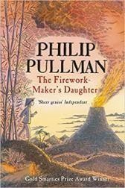  The Firework Maker’s Daughter | 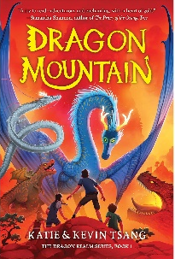  Chinese Traditions and Festivals | Butterfly Lion - Michel Morpurgo  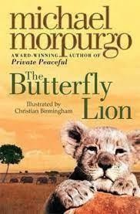 | 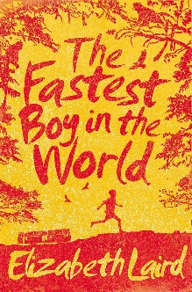 | Focus: Pig Heart Boy  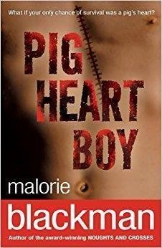 | 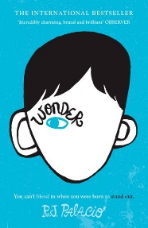  Focus ED: Wonder
Text types/genre  And number of weeks.  F – fiction  NF – non fiction  P - poetry | Diaries (F) (2 weeks)  Information texts (NF) (3 weeks)  Instructions intro (1 week) | Stories from different genres (F) (3 weeks)  Biographies (NF) (2 weeks)  Instructions (NF) (2 weeks) | Authors and texts (F) (2 weeks)  Argument discussion (NF) (3 weeks)  Poetry – Power of imagery (P) (2 weeks) | Short stories and flashbacks (F) (3 weeks)  Journalistic writing and commentaries (NF) (3 weeks) | Stories and creative writing (F) (3 weeks)  Formal/impersonal – (NF) (3 weeks)  Performance poetry (1 week) | Playscripts (F) (3 weeks)  Transition – autobiography (Non chron-report) (3 weeks)
SPAG content | - Informal and formal speech  - Abstract nouns  - Synonyms  - Antonyms (using prefixes)  - Collective nouns  - Passive and active  - Imperative verbs | - Inverted commas  - Repetition for effect  - Connectives  - Layout devices (headings, paragraphs, bullet points)  - Colons  - Semi colons | - Dashes  - Colon and bullet points for lists  - Hyphens for compound words  - Identify the subject and object of sentences  - Ellipses for suspense  Antonyms to create effects in sentences | - Semicolons to demarcate a list  - Alliteration  - Similes  - Metaphors  - Personification  - Fronted adverbials | - Simple sentences and how to embellish them  - Compound sentences  - Complex sentences  - Combining complex and compound clauses  - Rhetorical questions  Expanded noun phrases | - Modal verbs  - Auxiliary verbs  - Tenses  - Pronouns – relative and possessive  - Relative clauses  Determiners and generalisers
Handwriting and phonics/spelling | - Handwriting – following Penpals scope and sequence joins and style from Year 6. 2 or 3 sessions a week and assessed pieces.  - Spelling – NNS for Year 6. Weekly spelling tests and lists sent home to practice. Weekly spelling tests on Fridays.  - Independent proof reading and spelling strategies taught and modelled and opportunity for editing and improving work and redrafting. Use of dictionaries and thesauruses to edit and improve work.
Maths | Number and Place Value  Addition and Subtraction Multiplication and Division including  ratio and proportion  Asia - Time zones | Multiplication and Division contd.  Fractions, Decimals and Percentages  Population line graphs | Number Algebra Measure Converting units, distance, capacity, volume, areas, perimeter  Money - Costing a trip to Africa / Time zones | Measure Time and Money and Statistics – anything not covered in curriculum  Geometry – Properties of shapes, position and direction | Whole Year recaps, gap filling and application – AfL  Heart rates/ BMI/ Speed/distance graphs. | Investigations and Enterprise
Science | Light  Why does my shadow change length? | Electricity  How can electrical circuits be controlled? | Living Things and Habitats  Are all bacteria harmful? | Living Things and Habitats continued. | Why is the heart the most important pump we own?  The Human Body | How does evolution happen?  Evolution and Inheritance

History | The Shang Dynasty - China | The Shang Dynasty - China | South Africa and Apartheid. |  | Discovery of medicines and treatments. | The history of human evolution
Geography | Made in China (Trade and Economic Activity) | Made in China (Trade and Economic Activity) | Extreme Earth and It’s Amazing Places  African continent study - revisit Longitude and latitude. | Extreme Earth and It’s Amazing Places  Earthquakes, volcanoes, extreme habitats. |  | Awesome Oceans and Colossal Continents - Features of coasts and begin to understand erosion and deposition.  Residential Experience
Design and Technology | Chinese cooking and food tasting.  Making Great Wall of China models | Design a game project. Think about packaging, pitch the idea and selling to make profit. | Make traditional African instruments and jewellery  Research, design and make a rainwater harvester. | Volcano models using sturdy, reusable materials.  Use play dough to create a cross-section of the Earth and name its layers using cocktail sticks/labels. | Using computing software design and make an evolution chain with hyperlinks. | I can take part in adventurous outdoor activities; challenging myself and behaving safely.
Art and Design | Chinese writing | Light – still life | African Art - Edward | Angry earth | Self portrait | Free choice – a
 |  | Use of | Tingatinga | Use a full range of |  | ‘THEME’ is selected,
 | Chinese flower art | sketchbooks to |  | pencils, charcoal or | Know how to use a range of e- | and children can
 |  | document |  | pastels when creating a | resources to create art. Use | research ideas and
 |  | experiments/studi |  | piece of observational | this to experiment with | inspiration to create
 |  | es. |  | art. | creating and editing a self- | their own project.
 |  | Explain why |  | Carry out own research | portrait/photo of themselves. | Possible themes –
 |  | chosen specific |  | into |  | water, fire, war, life,
 |  | techniques have |  | lava/volcanoes/earth- |  | love. Etc.
 |  | been used know  how to use |  | based art. Use  sketchbook to document |  | Explain the style of art  used and how it has

 |  | feedback to make amendments and  improvement to art. |  | ideas and inspiration as it develops into final piece. |  | been influenced by a famous artist.
Physical Education | Tag Rugby  Forest School | Swimming  Forest School | Volleyball  Forest School | Gymnastics  Forest School | Rounders  Forest School | Basketball  Forest School
Computing | Internet communication Recognising how the WWW can be used to communicate and be searched to find information | Webpage creation Designing and creating webpages, giving consideration to copyright, aesthetics, and navigation. | Variables in games Exploring variables when designing and coding a game. | Introduction to spreadsheets Answering questions by using spreadsheets to organise and calculate data. | 3D modelling Planning, developing, and evaluating 3D computer models of physical objects. | Sensing Designing and coding a project that captures inputs from a physical  device.
RE | U2.1 Why do some people believe in God and some people not? (C, NR) | UC U2.2 Creation and science: conflicting or complementary? | U2.5 Is it better to express your belief in arts and architecture or in charity and  generosity? (C, M, NR) | UC U2.5 What do Christians believe Jesus did to ‘save’ people? | UC U2.6 For Christians, what kind of King is Jesus? | U2.3 What do religions say to people when life gets hard? (C, H, NR)
PSHE | Jigsaw - Being Me In My World | Jigsaw -  Celebrating Difference | Jigsaw - Dreams and Goals | Jigsaw - Healthy Me | Jigsaw - Relationships | Jigsaw - Changing Me
Music | Happy (Pop / Neo Soul) | Classroom Jazz 2  (Bacharach and Blues) | Three Little Birds  (Reggae) | You’ve Got a Friend (70’s Ballad / Pop) | Music and Me | Reflect, Rewind and Replay  (Classical)
Spanish | Revise Y5 through lessons | School | My Weekend Habitats (Geog) |  | Me in the World  Olympics ( Science / PE when  app.) or Healthy Lifestyle ( Science ) | Spanish Festivals

Spanish topic links may not be appropriate this year until basics are embedded

