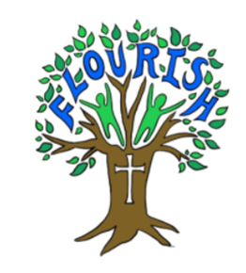
Handwriting and Presentation Policy
NEW: September 2022 (To be reviewed: September 2024)
Aims:
- To know the importance of clear and neat presentation in order to communicate meaning effectively.
- To write legibly in with increasing fluency and speed by.
- Having a correct pencil grip.
- Knowing the size and orientation of letters.
- Forming all letters correctly.
- Knowing which letters join and which are break letters.
Letter formation
When children enter school in Reception, they are taught letter formation according to the Little Wandle scheme (as of September 2022) and this teaching continues in Year 1.
Teaching time
Throughout EYFS and KS1 it is recommended that children have regular handwriting practise. At Escrick C of E Primary School, handwriting will be timetabled numerous times weekly, in short sessions, dependent on pupil age. This is reinforced through Little Wandle sessions when children write letters and sounds in the lower school. Children who find handwriting difficult will be targeted for regular intervention and additional practise.
Progression
EYFS – children are taught pencil grip, letter formation and motor skills according to the EYFS goals and Little Wandle coverage. (Appendix A)
Year 1 – consolidation of individual letter formation, by writing these as digraphs, trigraphs and words, following the Little Wandle teaching sequence. By Year 1, most children should be secure forming individual letters. However, some may still need small group support. The formation of all capital letters and numbers should be taught in Year 1.
Year 2 – Letter formation should now be secure. Joined handwriting will then be taught. We refer to Penpals Scope and Sequence (as of September 2022) using progressive objectives from Year 2 upwards. As the children in upper key stage 2 have not been taught this scheme previously, and due to large intake of pupils from outside catchment in recent times, KS2 teachers may choose to teach objectives for younger year groups at their own discretion.
Year 3 – Year 6 - children should continue to use joined writing but a number of children may need additional practise. This should follow the same progression as above:
- Correct pencil grip
- Correct letter formation
- Capitals and small letters correct size and orientation
- Joins progression – see Appendix B for Scope and Sequence
Presentation of work
- All work will have an LI/title or objective at the top. (This may be stuck in or written by the child/teacher, depending on age/ability).
- All work will be dated with the short date.
- Where possible, children should underline the title and date with a ruler.
- Writing should sit on the line and be an appropriate size.
- Children will write in pencil or black pen.
- Children will use purple pen to edit/redraft or make corrections to their work.
Appendix A – Little Wandle letters and sounds formation phrases

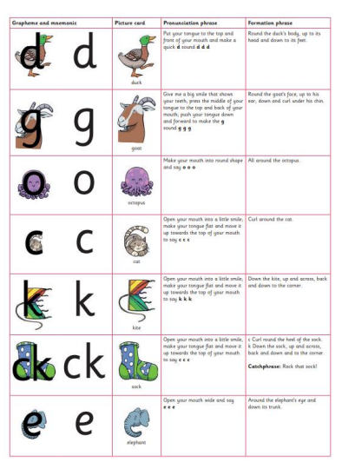
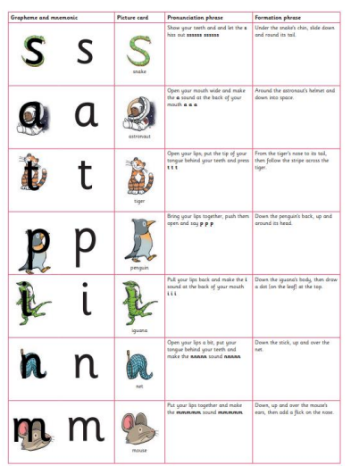

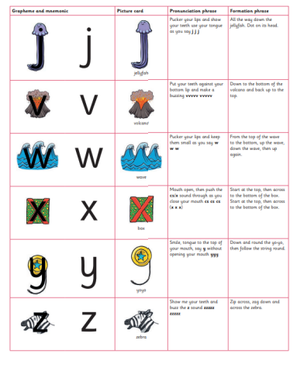
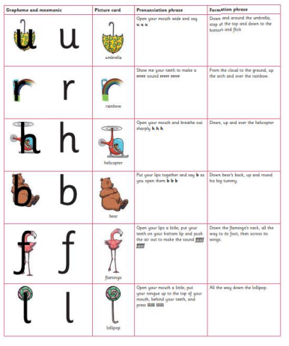

Appendix A (Continued) Little Wandle Capital letter formation
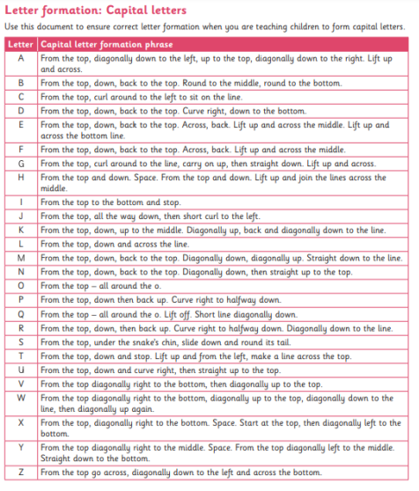

Appendix B Scope and Sequence attached at the back of this policy

