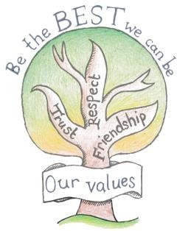At Escrick C of E Primary School, we want everyone to FLOURISH.

“Education is a partnership between school, children and parents.”

We expect our pupils to:
Work hard and try your best, showing resilience in all subjects and situations
Allow others to learn and follow instructions Wear school uniform
Complete your homework on time
Read regularly at home
Treat everyone with respect and kindness, showing tolerance and acceptance of differences

Talk to an adult at school or at home if you are unhappy

Look after your classroom, school equipment and the building

Signed: ………………………………………………………..

“Education is a partnership between school, children and parents.”

We hope that our families will:

Encourage your child(ren) to take a positive attitude towards school

Support the school’s policies

Make sure your child(ren) attend school and arrives at school on time, properly equipped and wearing full school uniform

Inform school in a timely manner if your child is absent

Attend parents’ events in school, where possible, including parent consultation evenings

Encourage your child to read at home regularly and complete any homework or home learning tasks set

Support the school in maintaining positive attitudes and behaviour

Make school aware of any concerns or issues that might affect your child’s work or behaviour

Read and respond to school communication

The family shall do its best to support our child(ren) and the school as indicated above,

Signed: …………………………………………………….
We value and respect everyone, allowing us all to make a difference to
the world.
Every person is an individual and also part of a Community.
1 Corinthians 12:12-27.
We will:

Provide a safe and engaging learning environment

Value every child as a unique and valuable member of our school family

Deliver a progressive, broad and balanced curriculum designed to develop both academic and non-academic skills

Encourage all children to develop their skills and talents

Foster high standards of work and behaviour through building good relationships and developing a sense of responsibility

Promote health and wellbeing in a variety of ways, including a focus on sports, outdoor learning and mindfulness

Promote equality and inclusion; prepare our children to be global citizens in an open and respectful manner

Be open and welcoming and invite families in to school when it is possible

Offer a firm and prompt response to all anti-social behaviour, including bullying or prejudice

Keep families well-informed about school matters and the progress of their child(ren), especially where there is a reason for concern or praise

Share information about class routines, including PE days and homework arrangements

Maintain close links with the parish of St Helen’s Church and the local community to further promote our Christian ethos

Signed Miss EE Miller ……………………………………………..

