SMSC and Fundamental British Values evidence for Escrick Church of England Primary School 2021 - 2022
Event and details  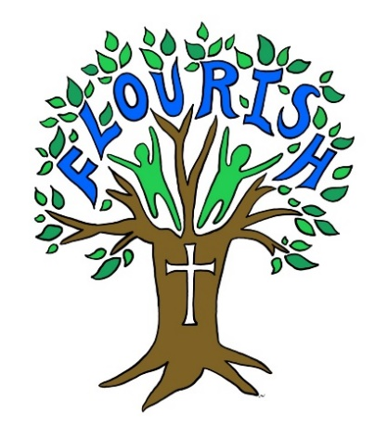 | SOCIAL |  |  |  | MORAL |  |  |  |  | SPIRITUAL |  |  |  |  | CULTURAL
 | Developing personal qualities & using social skills | Participating, co-operating and resolving conflicts | Understanding how communities and societies function | Develop an understanding of the Fundamental British Values of democracy and the rule of law. | Developing and expressing personal views or values | Moral codes and models of moral virtue | Recognising right and wrong and applying it | Understanding the consequences of actions | Investigating moral values and ethical issues | Developing personal values and beliefs | Experiencing fascination, awe and wonder | Exploring and respecting the values and beliefs of others | Understanding human emotions and feelings | Using imagination and creativity in learning | Exploring, understanding and respecting diversity | Participating in and responding to cultural activities | Understanding and appreciating personal influences
Whole School
Developing class rules
(September 2021)
Appointing Sports Leaders
(September 2021)
Election of Team Captains
(October 2021)
Election of Collective Worship Group and roles throughout the year
(September 2021)
Election of Well-being Warriors
(September 2021)
Harvest service at School
(October 2021)
Diwali
(November 2021)

SMSC and Fundamental British Values evidence for Escrick Church of England Primary School 2021 - 2022
Event and details | SOCIAL |  |  |  | MORAL |  |  |  |  | SPIRITUAL |  |  |  |  | CULTURAL
 | Developing personal qualities & using social skills | Participating, co-operating and resolving conflicts | Understanding how communities and societies function | Develop an understanding of the Fundamental British Values of democracy and the rule of law. | Developing and expressing personal views or values | Moral codes and models of moral virtue | Recognising right and wrong and applying it | Understanding the consequences of actions | Investigating moral values and ethical issues | Developing personal values and beliefs | Experiencing fascination, awe and wonder | Exploring and respecting the values and beliefs of others | Understanding human emotions and feelings | Using imagination and creativity in learning | Exploring, understanding and respecting diversity | Participating in and responding to cultural activities | Understanding and appreciating personal influences
Whole School
Creating prayers and poems for Remembrance Day (Nov 2021)
Remembrance Service in school including a two-minute silence
(November 2021)
Anti-bullying week
(Nov 2021)
EYFS Nativity
(December 2021)
Year 1 and Year 2 Christmas Production
(December 2021)
Key Stage 2 Christmas Performance of Lighting the Tree held outdoors
(December 2021)
Year 3 Music Ensemble for parents
(December 2021)
Whole School Advent Service including parents
Not held due to covid
Producing work for Church services and displays incl the Carol Service
(Ongoing)

SMSC and Fundamental British Values evidence for Escrick Church of England Primary School 2021 - 2022
Event and details | SOCIAL |  |  |  | MORAL |  |  |  |  | SPIRITUAL |  |  |  |  | CULTURAL
 | Developing personal qualities & using social skills | Participating, co-operating and resolving conflicts | Understanding how communities and societies function | Develop an understanding of the Fundamental British Values of democracy and the rule of law. | Developing and expressing personal views or values | Moral codes and models of moral virtue | Recognising right and wrong and applying it | Understanding the consequences of actions | Investigating moral values and ethical issues | Developing personal values and beliefs | Experiencing fascination, awe and wonder | Exploring and respecting the values and beliefs of others | Understanding human emotions and feelings | Using imagination and creativity in learning | Exploring, understanding and respecting diversity | Participating in and responding to cultural activities | Understanding and appreciating personal influences
Whole School
Participation with E-Safety Week
(January 2022)
E-Safety presentation for parents
Not held due to Covid
Visit to churches within the local community
(St Helen’s Year 5 – Nov 2021;
Year 6 – Jan 2022; reception - )
Easter Service at

FairTrade Afternoon to support the achievement of the FairTrade Award (April 2019)
Yr 6 attending the ‘Crucial Crew’ initiative
(July 2022)

SMSC and Fundamental British Values evidence for Escrick Church of England Primary School 2021 - 2022
Event and details | SOCIAL |  |  |  | MORAL |  |  |  |  | SPIRITUAL |  |  |  |  | CULTURAL
 | Developing personal qualities & using social skills | Participating, co-operating and resolving conflicts | Understanding how communities and societies function | Develop an understanding of the Fundamental British Values of democracy and the rule of law. | Developing and expressing personal views or values | Moral codes and models of moral virtue | Recognising right and wrong and applying it | Understanding the consequences of actions | Investigating moral values and ethical issues | Developing personal values and beliefs | Experiencing fascination, awe and wonder | Exploring and respecting the values and beliefs of others | Understanding human emotions and feelings | Using imagination and creativity in learning | Exploring, understanding and respecting diversity | Participating in and responding to cultural activities | Understanding and appreciating personal influences
Whole School
Residential Trip (Year 5/6)
(June 2022)
Collective Worship Themes that underpin all worship throughout the year
Communication of half termly Christian values with parents
(Ongoing)
Reception to Year 6 weekly Jigsaw Lessons for SRE and PSHE
(ongoing)
Charity Fundraising
(Throughout the school year)
Yr1 – Yr6 Level 2 sports competitions
(Throughout the school year)
Attendance of Yr6 Leavers’ Service at Selby Abbey

