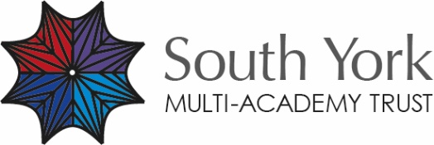

Safeguarding Statement
The South York Multi Academy Trust (SYMAT) are committed to safeguarding and promoting the welfare of children and young people within its family of schools. It expects all staff and volunteers to share this commitment.
We provide an inclusive, positive and caring environment in which our children and young people can develop their academic, social and emotional potential.
Every adult is expected to play their part in safeguarding our children and young people. Each school supports this through their offer of safeguarding and child protection awareness training. All staff in all our schools know the procedures that should be followed should they have any concerns about a student. All staff know where to go should they require some information, help and guidance.
The Trust supports each school in the following ways:
- The Trust fully adopts the Keeping Children Safe in Education September 2022 Guidance
- As a Trust we undertake safeguarding reviews and audits on an annual basis by an independent body that scrutinises our policy and procedures.
- The Trust is led by a Chief Executive who has ultimate responsibility for excellence in safeguarding
- Each school has its own Safeguarding Policy that details their school specific advice and designated safeguarding officer details
- Each school has a governor on its Governing Body with special responsibility for safeguarding.
Reporting Concerns
If you are concerned about the welfare of a pupil at any of our schools contact the relevant Designated Safeguarding Officer in each school. Details can be found in the Trust Policy and on each school website.
Trustees are responsible for safeguarding, even if certain aspects of the work are delegated to staff. Trustees must make a clear commitment to safeguarding and publish the safeguarding statement stating that failure to follow the statement will be dealt with as a very serious matter.

Statement Review Date | By Whom
September 2022 | Board of Trustees

