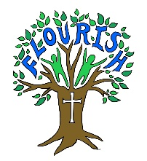
2022-2023
PE Curriculum Map
 | Autumn 1 | Autumn 2 | Spring 1 | Spring 2 | Summer 1 | Summer 2
EYFS | Introduction to PE  Forest School | Dance  Forest School | Ball Skills 1  Swimming | Fundamentals 1  Swimming | Ball Skills 2  Forest School | Games  Fore st School
Year 1 | Multi-skills  Forest School | Team-building  Forest School | Gymnastics  Swimming | Invasion Games  Swimming | Cricket  Forest School | Athletics  Forest School
Year 2 | Yoga  Forest School | Ball skills  Forest School | Gymnastics  Swimming | Tennis – Net & Wall  Swimming | Rounders  Forest School | Athletics  Forest School
Year 3 | Hockey  Swimming | Gymnastics  Swimming | Fitness  Forest School | Tag Rugby  Forest School | Tennis  Forest School | Athletics  Forest School
Year 4 | Hockey  Swimming | Gymnastics  Swimming | Dodgeball  Forest School | Orienteering  Forest School | Cricket  Forest School | Netball  Forest School
Year 5 | Hockey  Swimming | Gymnastics  Swimming | Badminton  Forest School | Netball  Forest School | Golf  Forest School | Handball  Forest School
Year 6 | Hockey  Swimming | Gymnastics  Swimming | Volleyball  Forest School | Handball  Forest School | Tchoukball  Forest School | Rounders  Forest School

