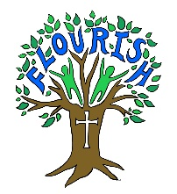
2022-2023
PE Progression of Skills

At Escrick, we recognise the importance of sequential and progressive skill development from EYFS to Year 6. We have adapted the Get Set 4 PE platform to plan and assess our PE lessons, using the progression document below. This ensures clarity for teachers when teaching specific skills and allows for consistent assessment using the statements for each year group.

