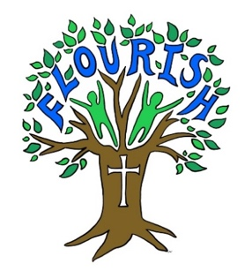

**Escrick Church of England Primary School Feedback and Marking Policy**

Introduction

At Escrick C of E Primary School, we give our pupils opportunities to flourish, encouraging them to develop a love of learning and aim for them to gain deep understanding of concepts in all areas of development and the curriculum. We encourage pupils to become independent and resilient learners within a community of enquiry and problem solving, thus our policy on Feedback and Marking encourages children to take some responsibility for their own learning as they grow.

Feedback and Marking at Escrick C of E Primary School

Feedback needs to be timely, concise and to meet the learning needs of each pupil. It should be consistent across the whole school. We mark and give feedback in the following ways:

1. Verbal feedback is given on most occasions. It is given to individuals, and in group or whole class situations, through mini plenaries and starters. VF is written in books when this happens. Verbal feedback is often given within a lesson to ensure children recognise strengths, address misconceptions or make maximum progress immediately.
2. Written responses are made at teacher discretion in green pen. Written responses may be used to support or challenge certain individuals.
3. Ticks, stamps, team points and stickers are used to indicate successes and positives within work.
4. Children self and peer mark against relevant success criteria set by the class teacher (Yrs 2-6) and edit and improve work using purple pens (KS2).
5. Teachers may annotate work, at their discretion, to show that work has been done independently by a child and when it has been completed in a group or with support.

Headteacher certificates are awarded weekly and work to be proud of is displayed on walls to recognise effort and achievement.

Success Criteria

We know our policy is working if;

* Children are making good progress.
* Children know what their strengths are and what areas they need to improve on in core subjects.
* Teacher’s planning is informed by feedback and marking.
* Pupil’s take note of feedback and act on it.
* Children have opportunity to reflect on their learning.
* Pupils speak positively about the impact feedback has on their learning and value this as an integral part of it.
* Subject leaders see the policy demonstrated in books and through pupil voice.
* Early years children know that teachers are evaluating their work using Tapestry.

**Marking and Feedback during school restricted opening:**

Some of the above principles still apply when we deliver remote teaching and learning.

The majority of feedback between school and home is done via short VF style comments typed privately to the pupil relating to work submitted. Pupils are praised and given ways forward/ encouraged to improve, as appropriate, as they would be in school. For further information on teaching and learning during restricted opening, please see our Home Learning Policy.

Updated: January 24

Policy Review Date: January 25