

**Escrick Church of England**

**Computing Policy**

At Escrick Primary School, we believe that our curriculum should be broad, balanced, creative and relevant and should meet the needs of all our learners whatever their ability. We strive to develop in pupils: curiosity, creativity, enjoyment, skills and a growing understanding of computing.

**Intent**

**Pupils will be familiar with a range of technology, understanding how it works, how it can enhance their learning and how they can code and control it themselves. They will also learn to become competent and critical users of digital content and the worldwide web, understanding how to be safe and responsible when using technology.**

Computing sessions are an opportunity for pupils to problem solve, follow instructions, understand complex systems and algorithms and use technology to enhance their work in other subjects. They will learn how to use algorithms to create and develop simple programs, use reasoning to solve problems and ‘bugs’ within complex algorithms, to understand how different networks operate and making decisions about which online content/sites are trustworthy. Alongside developing a skillset for coding and computer science, pupils should also become efficient users of technology for a range of purposes: databases, photo and video editing, producing sound and music, presentations and a range of other basic skills that are essential for becoming confident users of technology.

Google Classroom can be used by class teachers in computing skills sessions to assign tasks and allow teachers to see pupil’s work on screen and give immediate teacher feedback in electronic form. This ensures that pupils can address issues and are challenged to improve within the lesson.

Our intentions for teaching computing at Escrick Primary School is to ensure all pupils are:

* provided with a relevant, challenging, and enjoyable curriculum for computing.
* meeting the requirements of the National Curriculum programmes of study for computing.
* using computing as a tool to enhance learning throughout the curriculum.
* responding to new developments in technology.
* equipped with the confidence and capability to use computing throughout their later life.
* learning computing in other areas of the curriculum.
* developing their understanding of how to use computing safely and responsibly (with the addition of remote learning).

**Safeguarding**

We understand the important role the we play as a community in keeping children safe when using technology, both at school and at home. Our internet safety policy and relevant documents are reviewed by all stakeholders and governors. There is a separate policy for internet safety at Escrick School and a progression document specifically for teaching internet safety at an appropriate level for different year groups – teachers refer to this when planning sessions.

Our SYMAT uses a high level protection of Smooth wall and filtering also adds an extra level of safeguarding when children are using the internet. In addition to this, children are reminded of our online user agreement which outlines key rules and actions to take if unsuitable content is shown.

Through the use of Teach Computing (Our Scheme of work) the unit overviews for each unit show the links between the content of the lessons and the National Curriculum. These references have been provided to show where aspects relating to online safety, or digital citizenship, are covered within the Teach Computing Curriculum. Not all internet safety is taught through computing session as we recognise some objectives are better suited to personal, social, health, and economic (PSHE) education; spiritual, moral, social, and cultural (SMSC) development (and delivered in Jigsaw sessions or collective worship).

**Planning and implementation**

Long term planning is based on the The National Curriculum 2014 for Computing. Here at Escrick Primary we follow the Teach Computing scheme of work. It is important to ensure coverage of the three core strands of the computing curriculum, ensuring that the internet safety strand is taught regularly in PSHE sessions and discrete lessons each term. This is also supported by information shared with parents and whole school/Key Stage assemblies, where appropriate.

The Teach Computing curriculum is structured into units for each year group and lessons can generally be taught in any order, with the exception of programming, where concepts and skills rely on prior knowledge and experiences.

The units for Key Stages 1 and 2 are based on a spiral curriculum. This means that each of the themes is revisited regularly (at least once in each year group), and pupils revisit each theme through a new unit that consolidates and builds on prior learning. This style of curriculum design reduces the amount of knowledge lost as topics are revisited yearly. It also ensures that connections are made between topics from year to year.

Computing lessons do not always require laptops or technology – objectives such as ‘writing an algorithm’ or ‘understand what computer networks do’ can be done through discussion and other practical activities. However, children have the opportunity to use laptops, iPads and Chromebooks and other digital devices as part of their computing curriculum from Reception to Year 6. In Year 5 and 6, pupils have access to small devices called Micro bits which are physical devices that can be programmed using coding.

Equal opportunities in computing will be given to all pupils and plans will be made for how to include all pupils in computing sessions. Children with an EHCP often have personalised objectives for computing sessions and have access to individual laptops and personalised apps. They are supported in accessing these.

**Programme of Study (Implementation)**

By the end of each Key Stage, pupils are expected to know, apply, and understand the

matters, skills, and processes outlined in our Teach Computing programme of study.

**Early Years**

It is important in the foundation stage to give children a broad, play-based experience

of computing in a range of contexts, including outdoor play. Computing is not just about

computers. Early years learning environments should feature computing scenarios based

on experience in the real world, such as in role play. Children gain confidence, control

and language skills through opportunities to ‘paint’ on laptops, take photos with the ipad or program a toy (Such as a Beebot).

**Unit Summaries**

Below is an overview of the LTP units taught through Teach Computing. It shows the spiral curriculum and how each topic progresses each year, building on prior learning and improving and extending their vocabulary in each area.

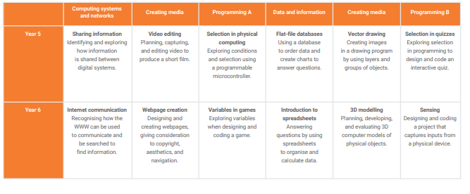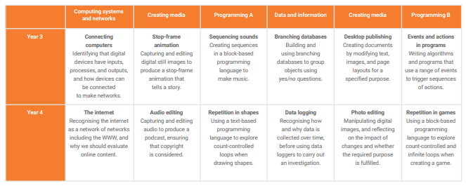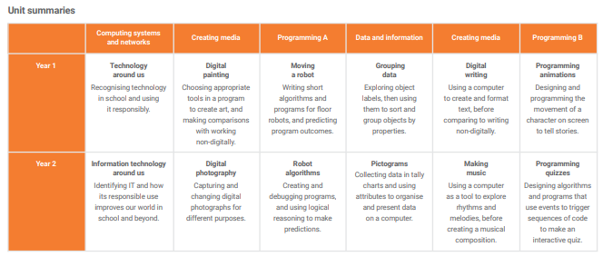

**Key Stage 1**

By the end of Key Stage 1 children should be able to:

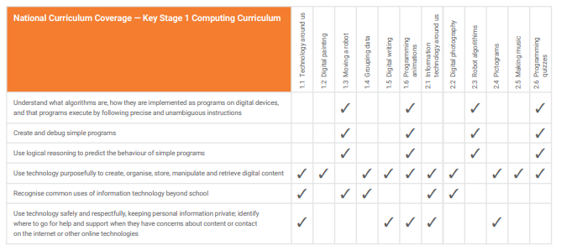

**Key stage 2:**

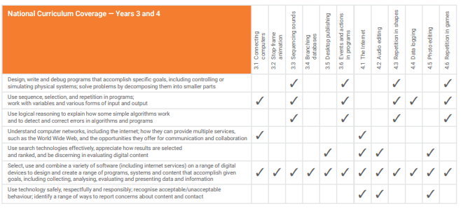

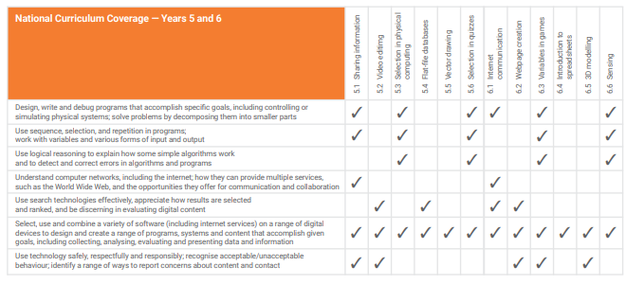

**Assessment and reporting**

To assess pupils' progress in computing we make termly summative teacher assessments and a formative end of year assessment of progress. Work produced in sessions, observations of independence and finished projects can all be used as evidence. Pupil voice interviews may also provide an idea of the skills and learning that children have gained in computing sessions. Teachers pass assessment information on to the next year group to ensure progression. Teachers then report annually to parents on how well the pupil has achieved in computing.

**The role of the computing subject leader is to:**

* provide leadership and direction for the subject
* monitor planning and progression in the subject
* play a key role in supporting, and providing resources for, teachers in the subject
* evaluate effectiveness of teaching and learning, the subject curriculum and progress towards pupils meeting year group standards through regular monitoring
* understand how the subject contributes to the SDP

The computing subject leaders will carry out work scrutinies, discussions with stakeholders and learning visits, monitor assessments and deliver staff training as appropriate.

The Computing subject leaders will ensure this policy is kept up to date.

Reviewed: Nov 2024

To be updated Nov 2026