
ESCRICK CE PRIMARY SCHOOL

POSITIVE BEHAVIOUR POLICY (including Anti-Bullying)

Date of Policy: September 2024
Date of Review: September 2025
Member(s) of staff responsible: Emma Miller
Governor(s) responsible: JW

Rights Respecting
Escrick Primary is a Rights Respecting School which means that everyone puts the rights of the child at the heart of our school. All children have rights as detailed by the UNCRC (United Nations Convention on the Rights of the Child). Everyone in our school has the right:
- To feel safe, healthy and happy
- To be treated with respect, dignity and equality.
- To learn or to teach, or to do their job.
Article 29 of the UNCRC.
A rights-respecting school not only teaches about children’s rights but also models rights and respect in all its relationships: between teachers/adults and pupils, between adults and between pupils. All staff are encouraged to use praise and whole school consequence charts to help pupils achieve their best work and respect the rights of everyone.
Our Behaviour Policy is designed to acknowledge and reward pupils’ good attitudes, behaviours and work that respects the rights of everyone. Positive consequences are both important influences in motivating pupils and building self-esteem.
Whilst emphasising behaviour that respects the rights of everyone, we also establish negative consequences. Children know and understand behaviour that respects the rights of everyone in our school and are encouraged to choose behaviour that will help everyone around them.
Rationale
At Escrick C of E Primary School, we embed values that allow our children to FLOURISH throughout their time with us. We promote the Christian values of wisdom, joy and tolerance alongside thankfulness and forgiveness. We have a culture of respect and encourage our children to learn from their mistakes and show resilience in challenging situations. Our Zero tolerance approach underpins the behaviours of our children as they are taught about their rights and responsibilities in school and the wider community. In our school we seek to maintain a Christian ethos and try to act with courtesy and consideration for others at all times. These are the values we are all working towards to make our school a happy place in which to grow and learn:-
Friendship
Learning
Opportunities
Unique
Respect and resilience
Included
Solve problems
Happy

We actively promote values of respect and equality and work to ensure that difference and diversity is celebrated across the whole school community. We want to enable our pupils to become responsible citizens and to prepare them for life in 21st Century Britain. These values reflect those that will be expected of our pupils by society, when they enter secondary school and beyond in the world of work and study.

AIMS AND PURPOSE OF THE POLICY
• To encourage a calm, purposeful and happy atmosphere within the school.
• To teach pupils about the rights of a child (UNCRC) and how these rights have responsibilities.
• To foster positive caring attitudes towards everyone where achievements at all levels are acknowledged and valued.
• To encourage increasing independence and self-discipline so that each child learns to accept responsibility for his/her own behaviour.
• To have a consistent approach to behaviour throughout the school with parental co-operation and involvement.
• To make the boundaries of acceptable behaviour clear and to ensure safety.
• To raise awareness about appropriate behaviour.
• To give pupils, staff and parents a shared sense of direction and feeling of common purpose.
At Escrick Primary School we have three simple rules:
‘Be Ready, Be Respectful and Be Safe’
They can be applied to a variety of situations and are taught and modelled explicitly. We also understand that for some pupils, following our behaviour expectations are beyond their developmental level. In this case, these children will have bespoke behaviour strategies which may include alternative provision to reinforce positive behaviour.
By keeping to these rules, our pupils can:
- feel ready to learn feel safe, secure and respected;
- learn to care for, include and support one another;
- learn the value of friendship;
- show resilience and be proud of all their achievements;
- develop their own self-confidence and feel happy at school;
- try their best, learn and make the most of opportunities provided;
- learn to care for their school and environment;
- understand Christian Values such as forgiveness.

Staff can:
- teach more effectively and foster a love of learning;
- develop positive relationships with pupils and parents;
- meet the needs of all pupils so all pupils learn and have equal opportunities;
- work in a happy atmosphere of mutual trust and respect;
- feel supported in their roles;
- develop personally and professionally.

Parents:
- know that their children feel safe and happy in school;
- feel confident that their children are growing personally, socially and academically;
- feel valued as partners in their children's education;
- promote school rules and respect school decisions
- support school by respecting zero tolerance at home and school.

How to encourage positive behaviour in school:
- we discuss the consequences of positive and negative behaviour with each class; using Restorative Practice.
- we treat each child fairly, equally and with respect and compassion;
- we recognise and celebrate good behaviour as it occurs;
- we explain and model the behaviour we wish to see;
- we encourage children to be responsible for their own actions and choices;
- we use the PSHE curriculum and Zones of Regulation to further embed positive behaviours and to support children with self-regulation strategies to manage their feelings and emotions.
- we reflect and use collective worships times emphasise our Christian Values and how they underpin our daily behaviours;
- the children have a voice in establishing school and class rules

Behaviour and Consequences
Our behaviour policy revolves around an education of ‘consequences’ (See Appendices 1 and 2) instead of rewards and sanctions. This links to our PSHE curriculum where the concept of ‘consequences’ is key to children understanding how to make appropriate and safe choices. We believe that behavioural practices that utilise the systems of sanction and reward do not necessarily address the complexities of social and emotional needs of pupils, particularly those who are vulnerable, in need and/or high-risk of under achievement.
We believe that children must be helped to understand that there can be positive and negative consequences of their behaviour. We strive to help children understand positive consequences and to help children feel the intrinsic value in relationships. We believe that used helpfully, consequences rather than ‘sanctions’ can be effective in showing and teaching children how to behave, by providing a climate of mutual respect, where problems are seen as opportunities for learning and growth. Children are supported to learn from their mistakes through natural and logical consequences, increasing children’s resilience and self-discipline.
Zones of Regulation
We recognise the importance of promoting positive mental health and emotional wellbeing to our pupils and their families. We aim to create an open culture around the discussion of mental health and wellbeing and to empower our children be able to regulate their emotions. By implementing the Zones of Regulation curriculum throughout school we aim to teach our pupils to identify emotions in themselves and others and provide them with bank of strategies to help regulate their emotions and improve their wellbeing.
The Zones of Regulation is a curriculum based around the use of four colours to help children self-identify how they’re feeling and categorise it based on colour. The curriculum also helps children better understand their emotions, sensory needs and thinking patterns. The children learn different strategies to cope and manage their emotions based on which colour zone they’re in. By enabling children to tune in more explicitly to their emotions and problem-solve solutions that will help them to manage such feelings, and the behavioural consequences of those feelings, the child is engaged in pro-actively enhancing their social and emotional competences and developing their ability to regulate their behaviour when needed. All children in school are familiar with the concept of Zones of Regulation and it is referred to daily by teachers in class. Children and classes have specific Zones of Regulation lessons where teachers feel necessary. There is progression across the curriculum with children in Early Years learning to identify different emotions to children in Upper Key Stage 2 discussing how our behaviour can impact upon the feelings of those around us.
In School, we recognise good behaviour by:
- moving children on the positive behaviour consequences chart (See Appendix 1)
- praise and encouragement; the school operates a positive approach to behaviour management and values positive interactions with children
- stickers, certificates, team points and head teacher awards;
- hearing about good behaviour in assemblies;
- positive messages home;
- individual, group or class privileges;
- greater responsibilities for individual children e.g. well-being champions, team captains, members of pupil voice groups.

What is unacceptable behaviour?
- deliberate disruption to the learning of others
- red offences (See list)
- physical or verbal violence towards others
- refusal to obey reasonable requests
- deliberate damage to property
- bullying of any kind

Discouraging unacceptable behaviour - On occasions, when a child behaves unacceptably, staff will:
- remind pupils of the school rules: Ready, Respect and Safe (particularly those which have been broken)
- move children on the negative behaviour consequences chart (See Appendix 2 and outlined below)
- use step 1: remind the child verbally about positive behaviour
- use step 2: provide a verbal warning to the child about their behaviour
- use step 3: the child may be asked to work alone or in a different part of the classroom
- use step 4: the child may lose 5 minutes of their breaktime or an activity chosen by the teacher
- use step 5: the child may lose all of their breaktime and be sent to the headteacher for reflection time

Sometimes this may not be enough, depending upon the situation and it may be necessary to deal with misbehaviour by:
- giving a firm reprimand
- separating pupils within the class
- removing privileges such as playtime, more than one playtime, class positive consequences, or after school clubs from individuals
- using reasonable force to move a child/ group to safety (with reference to our positively handling policy)
- writing a letter of apology or saying sorry
- work not completed in the lesson may be sent home to be completed
- repairing the damage, by clearing up the ess, repairing the displays, making up with peers
- referring child to the Deputy Headteacher or Headteacher
- contacting parents to discuss ways of helping the child to improve his/her behaviour

Our Restorative Approach
All staff will:
1. Meet and greet at the door.
2. Refer to ‘Ready, Respectful and Safe’
3. Model positive behaviours and build relationships.
4. Plan lessons that engage, challenge and meet the needs of all learners.
6. Be calm and when going through the steps. Prevent before using negative consequences.
7. Follow up every time, retain ownership and engage in reflective dialogue with children.
8. Never ignore or walk past children behaving in an unacceptable manner.
Senior leaders:
Senior leaders are not expected to deal with behaviour referrals in isolation. Rather they are to stand alongside colleagues to support, guide, model and show a unified consistency to the children.
Senior leaders will:
• Meet and greet learners at the beginning of the day
• Be a visible presence around the school and especially at transition times
• Celebrate staff, leaders and learners whose effort goes above and beyond expectations
• Regularly share good practice
• Support staff in managing learners with more complex or entrenched negative behaviours
• Regularly review provision for learners who fall beyond the range of written policies
• Be a daily visible presence around the school, both inside and outside and particularly at times of mass movement.
Online misbehaviour
The school can issue behaviour consequences to pupils for online misbehaviour when:
- It poses a threat or causes harm to another pupil
- It could have repercussions for the orderly running of the school
- It adversely affects the reputation of the school
- The pupil is identifiable as a member of the school
Negative consequences will only be given out on school premises or elsewhere when the pupil is under the lawful control of a staff member.
Additional Needs:
We always strive to include, not exclude, and approach all incidents of challenging behaviour using a supportive and restorative approach. This policy has been reviewed and deemed appropriate in meeting the needs of the majority of the pupils in our school by our staff team. We, of course, will adapt our practices, when required, to support individual children with their behaviour and actions, especially those with SEND needs.
Some additional measures that may be put in place to do this are listed below:
- an individual support plan devised to meet the child’s behavioural needs;
- behaviour interventions created in conjunction with parents (e.g. daily report card);
- pastoral support provided by a staff member or outside agency.
Recognising the impact of SEND on behaviour
The school recognises that pupils’ behaviour may be impacted by a special educational need or disability (SEND).
When incidents of misbehaviour arise, we will consider them in relation to a pupil’s SEND, although we recognise that not every incident of misbehaviour will be connected to their SEND. Decisions on whether a pupil’s SEND had an impact on an incident of misbehaviour will be made on a case-by-case basis.
When dealing with misbehaviour from pupils with SEND, especially where their SEND affects their behaviour, the school will balance their legal duties when making decisions about enforcing the behaviour policy. The legal duties include:
- Taking reasonable steps to avoid any substantial disadvantage to a disabled pupil being caused by the school’s policies or practices (Equality Act 2010)
- Using our best endeavours to meet the needs of pupils with SEND (Children and Families Act 2014)
- If a pupil has an education, health and care (EHC) plan, the provisions set out in that plan must be secured and the school must co-operate with the local authority and other bodies
As part of meeting these duties, the school will anticipate, as far as possible, all likely triggers of misbehaviour, and put in place support to prevent these from occurring.
Any preventative measures will consider the specific circumstances and requirements of the pupil concerned.
Adapting consequences for pupils with SEND
When considering a behavioural consequence for a pupil with SEND, the school will consider:
- Was the pupil unable to understand the rule or instruction?
- Was the pupil unable to act differently at the time as a result of their SEND?
- Is the pupil likely to behave aggressively due to their particular SEND?
If the answer to any of these questions is ‘yes’, it may be unlawful for the school to consequence the pupil for the behaviour.
The school will then assess if it is appropriate to use a consequence and if so, whether any reasonable adjustments need to be made to the consequence.
Considering whether a pupil displaying challenging behaviour may have unidentified SEND
The school’s special educational needs co-ordinator (SENCO) may evaluate a pupil who exhibits challenging behaviour to determine whether they have any underlying needs that are not currently being met. Where necessary, support and advice will also be sought from specialist teachers, an educational psychologist, medical practitioners and/or others, to identify or support specific needs.
When acute needs are identified in a pupil, we will liaise with external agencies and plan support programmes for that child. We will work with parents/carers to create the plan/ report and review it on a regular basis.
Pupils with an education, health and care (EHC) plan
The provisions set out in the EHC plan must be secured and the school will co-operate with the local authority and other bodies. If the school has a concern about the behaviour of a pupil with an EHC plan, it will contact the local authority to discuss the matter. If appropriate, the school may request an emergency review of the EHC plan.
Contacting Parents about negative consequences:
Cases are individual so communication with parents will be undertaken if deemed necessary
Parents may be informed if their child has had to miss a full playtime by the adult administering the negative consequence
Parents will be informed if their child has had to regularly miss parts of a playtime by their class teacher or member of the SLT
RESTRAINING PUPILS
All members of staff are aware of the regulations regarding the use of reasonable force to control or restrain pupils. Teachers in our school do not hit, push or slap children. Staff only intervene physically to restrain children or to prevent injury to a child, or if a child is in danger of hurting him/herself. The actions that we take are in line with government guidelines on the restraint of children. Most members of staff have received ‘Team Teach’ accredited training on positive handling.
FIXED-TERM AND PERMANENT EXCLUSIONS
We do not wish to exclude any child from school, but sometimes this may be necessary following a serious incident. The school will follow the DfE current guidelines on exclusions in such circumstances
Behaviour off school site
Consequences may be applied where a pupil’s behaviour impacts on the learning or wellbeing of students off-site when representing the school, such as on a school trip.
SCHOOL STATEMENT ON BULLYING
Bullying of any kind is unacceptable and will not be tolerated at our school. At our school the safety, welfare and well-being of all pupils and staff is a priority. We take all incidences of bullying seriously and it is our duty as a whole school community to take measures to prevent and tackle any bullying, harassment or discrimination.
DEFINITION OF BULLYING
Bullying is hurtful or unkind behaviour which is deliberate and repeated. Bullying can be carried out by an individual or a group of people towards an individual or group. The STOP acronym can be applied to define bullying – Several Times On Purpose.
The nature of bullying can be:
• Physical- such as hitting or physically intimidating someone, or using inappropriate or unwanted physical contact towards someone
• Attacking property- such as damaging, stealing or hiding someone’s possessions
• Verbal- such as name –calling, spreading rumours about someone, using derogatory or offensive language or threatening someone
• Psychological – such as deliberately excluding or ignoring people
• Cyber – such as using text, email or other social media to write or say hurtful things about someone Bullying can be based on any of the following things:
• Race (racist bullying)
• Religion or belief
• Culture or class
• Gender (sexist bullying)
• Sexual orientation (homophobic or biphobic bullying)
• Gender identity (transphobic bullying)
• Special Educational Needs (SEN) or disability
• Appearance or health conditions
• Related to home or other personal situation
• Related to another vulnerable group of people No form of bullying will be tolerated and all incidents will be taken seriously

REPORTING BULLYING FOR PUPILS WHO ARE BEING BULLIED
If a pupil is being bullied they are encouraged to not retaliate but to tell someone they trust about it such as a friend, family member or trusted adult.
They are also encouraged to report any bullying incidents in school:
• Report to a teacher – their class teacher or any other teacher
• Tell a friend, prefect or playground leader who in turn can help them tell a teacher or member of staff
• Tell any other adult staff in school – such as lunchtime supervisors, Support staff or members of the school office team
• Tell an adult at home
• Report anonymously (using class and whole school worry boxes)
REPORTING – ROLES AND RESPONSIBILITIES STAFF
All school staff, both teaching and non-teaching (for example midday supervisors, caretakers, volunteers) have a duty to report bullying, to be vigilant to the signs of bullying and to play an active role in the school’s measures to prevent bullying. If staff are aware of bullying, they should reassure the pupils involved and inform their class teacher.
SENIOR STAFF: The Senior Leadership Team and the head teacher have overall responsibility for ensuring that the anti-bullying policy is followed by all members of staff and that the school upholds its duty to promote the safety and well-being of all young people.
PARENTS AND CARERS: Parents and carers should look out for potential signs of bullying such as distress, lack of concentration, feigning illness or other unusual behaviour. Parents and carers should encourage their child not to retaliate and support and encourage them to report the bullying. Parents and carers can report an incident of bullying to the school either in person, or by phoning or emailing the school office or a member of staff.
PUPILS: Pupils should not take part in any kind of bullying and should watch out for signs of bullying among their peers. They should never be bystanders to incidents of bullying, but should offer support to the victim and, if possible, help them to tell a trusted adult.
RESPONDING TO BULLYING
When bullying has been reported, the following actions will be taken:
• Staff will record the bullying centrally on CPOMs
• SLT will be alerted
• Designated school staff will monitor incident reporting forms and information recorded on CPOMs analysing and evaluating the results
• Designated school staff will produce termly reports summarising the information, which the head teacher will report to the governing body
• Staff will offer support to the target of the bullying in discussion with the pupil’s class teacher. Individual meetings will then be held with any target of bullying to devise a plan of action that ensures they are made to feel safe and reassured that the bullying is not their fault. Action plans will make use of school initiatives such as buddy systems and playground monitoring.
• Staff will pro-actively respond to the bully who may require support. They will discuss with the target’s class teacher to devise a plan of action
• Staff will inform parents or carers and where necessary involve them in any plans of action
• Staff will assess whether any other authorities (such as police, social services) need to be involved, particularly when actions take place outside of school
BULLYING OUTSIDE OF SCHOOL
Bullying is unacceptable and will not be tolerated, whether it takes place inside or outside of school. Bullying can take place on the way to and from school, before or after school hours, at the weekends or during the holidays, or in the wider community. The nature of cyber bullying in particular means that it can impact on pupils’ well-being beyond the school day. Staff, parents and carers, and pupils must be vigilant to bullying outside of school and report and respond according to their responsibilities as outlined in this policy.
DEROGATORY LANGUAGE
Derogatory or offensive language is not acceptable and will not be tolerated. This type of language can take any of the forms of bullying listed in our definition of bullying. It will be challenged by staff and recorded and monitored on CPOMs and follow up actions and consequences, if appropriate, will be taken for pupils and staff found using any such language. Staff are also encouraged to record the casual use of derogatory language using informal mechanisms such as a classroom log.
PREJUDICE-BASED INCIDENTS
A prejudice-based incident is a one-off incident of unkind or hurtful behaviour that is motivated by a prejudice or negative attitudes, beliefs or views towards a protected characteristic or minority group. It can be targeted towards an individual or group of people and have a significant impact on those targeted. All prejudice-based incidents are taken seriously and recorded and monitored in school, with the head teacher regularly reporting incidents to the governing body. This not only ensures that all incidents are dealt with accordingly, but also helps to prevent bullying as it enables targeted antibullying interventions.
SCHOOL INITIATIVES TO PREVENT AND TACKLE BULLYING
We use a range of measures to prevent and tackle bullying including:
• The PSHE programme of study includes opportunities for pupils to understand about different types of bullying and what they can do to respond and prevent bullying
• School assemblies help raise pupils’ awareness of bullying and derogatory language
• Difference and diversity are celebrated across the school through diverse displays, books and images. The whole school participates in events including Anti-Bullying Week and Children’s Mental Health Week.
• The school values of FLOURISH are embedded across the curriculum to ensure that it is as inclusive as possible
• Stereotypes are challenged by staff and pupils across the school
• Playground leaders and Prefects offer support to all pupils, including those who may have been the target of bullying
• Pupils are continually involved in developing school-wide anti-bullying initiatives through consultation with groups
• Working with parents and carers and in partnership with community organisations to tackle bullying, where appropriate
TRAINING
The head teacher is responsible for ensuring that all school staff, both teaching and non-teaching (including midday supervisors, caretakers and librarians) receive regular training on all aspects of the anti-bullying policy.
MONITORING AND REVIEW
The headteacher monitors the effectiveness of this policy on a regular basis. The head teacher is also responsible for reporting to the governing body on how the policy is being enforced and upheld, via the termly report. The governors are in turn responsible for monitoring the effectiveness of the policy via the termly report and by in-school monitoring such as learning walks and focus groups with pupils. The governing body reviews this policy every two years. The governors may, however, review the policy earlier than this if the government introduces new regulations, or if the governing body receives recommendations on how the policy might be improved.
This policy applies to all staff and to all pupils, whether temporarily or permanently on the school roll.
Policy Approved: September 2023 Date for reviewing: September 2024

Red Offences:

Kicking, hitting, hair pulling, biting, verbal abuse, swearing, inappropriate language incl discriminatory or prejudice of any kind. Behaviours of a sexual nature, low level disruption, refusal to complete work.

Appendix 1

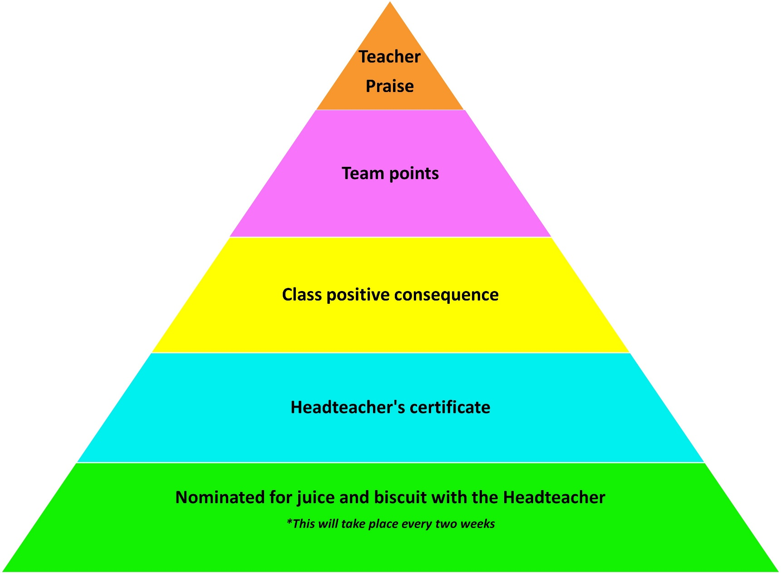

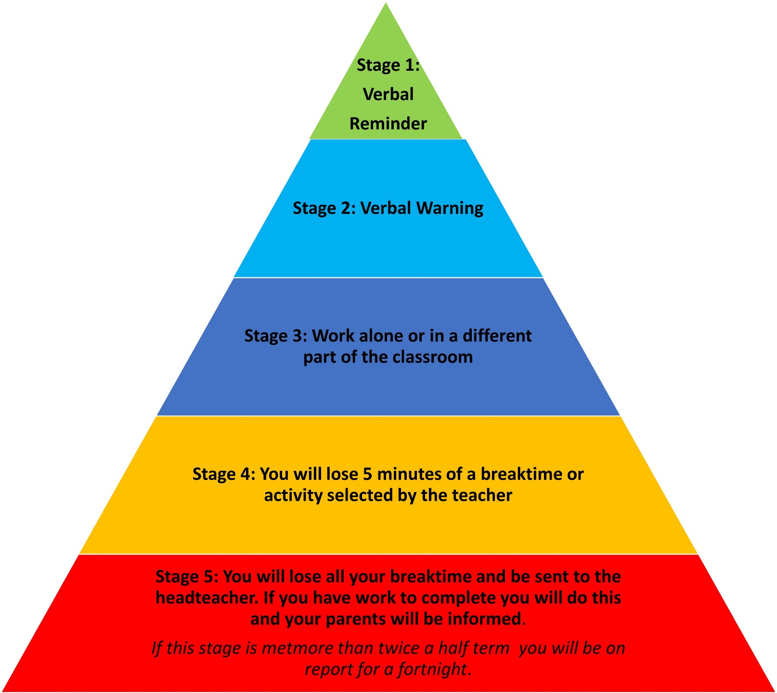
Appendix 2

