PE Funding

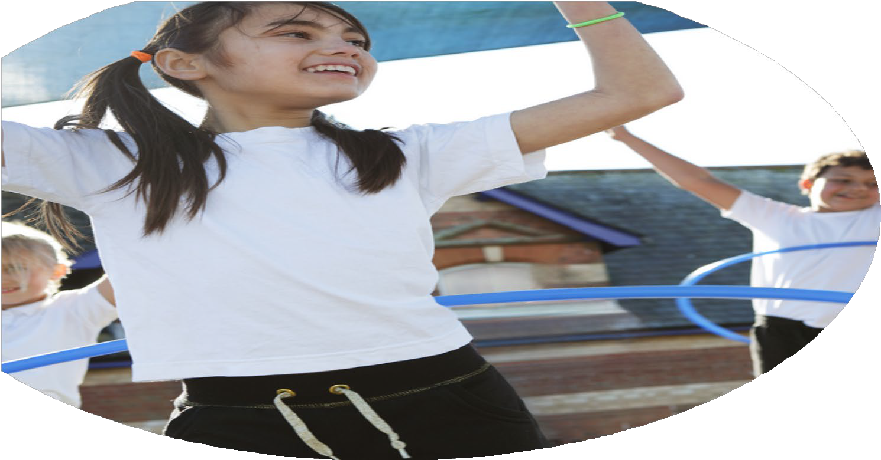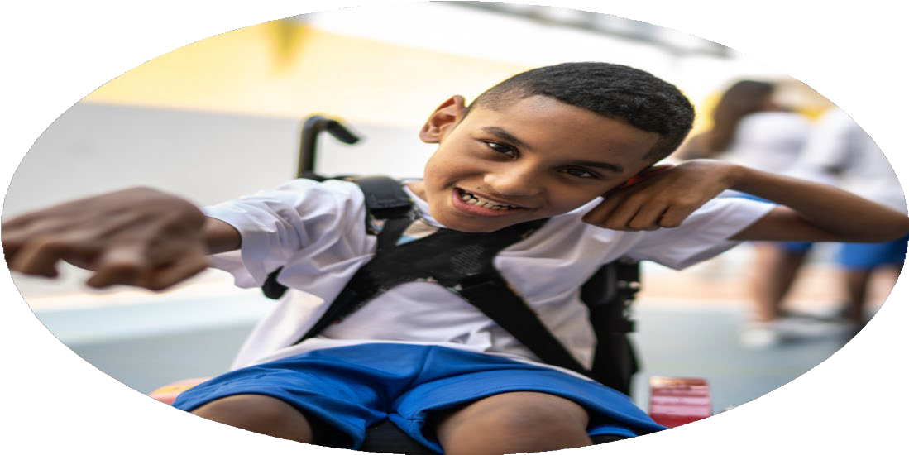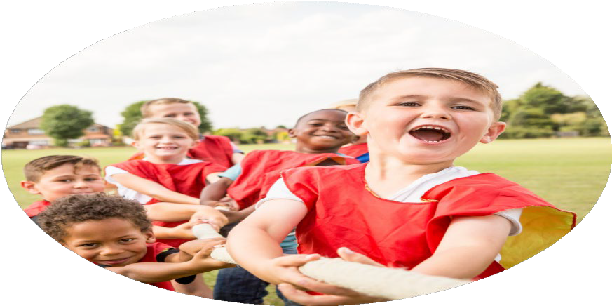

Evaluation Form

**Commissioned by**

**Created by**

Images courtesy of Youth Sport Trust

**PE Funding Evaluation Form**

 It is intended that this template should be used as preparation for the completion of the statutory digital reporting tool being introduced this academic year. You can upload data (including swimming) from this template onto this platform once it becomes accessible.

 Before you decide how you are going to use the funding for this academic year you should reflect and evaluate the impact of your use of the funding in 2023/24.

 All spending of the funding must conform with the terms outlined in the Conditions of Grant document.  The template is a working document that you can amend/update during the year.

 Based on your evaluation of last year’s funding you should decide what you intend to do this academic year, how you will do it, and what impact you expect it to have.

It is important that the funding is used effectively and based on your school’s needs.

 You must use the funding to make additional and sustainable improvements to the PE and sport in your school.  You must develop and add to the PESSPA activities that your school already offers.

*Summative digital reporting from June 2025 will continue to include swimming and water safety information therefore funding can be used to provide top-up lessons where necessary to ensure pupils meet national curriculum swimming requirements.*

**Review of Previous Spend and Impact of Current Provision**

In the previous academic year, we invested a total of **£17,560** to enhance the quality and breadth of our physical education and enrichment offer. This funding supported a wide range of initiatives aimed at improving pupil engagement, promoting healthy lifestyles, and upskilling staff.

Our spend included:

* **Dance workshops** for all classes, encouraging creativity, physical expression, and coordination.
* **‘Bikeability’ lessons** for Year 6 pupils, equipping them with essential cycling and road safety skills.
* A **subscription to Premier Education**, providing weekly specialist PE lessons for all classes, ensuring high-quality, consistent PE delivery across the school.
* A subscription to the YSSN Sports Package to provide us with access to local and regional sporting events and opportunities.
* Access to an **online portal** with CPD opportunities, lesson plans, and teaching resources, supporting staff development and improving the quality of PE teaching.
* A range of **afterschool clubs and wider curriculum opportunities**, such as fencing, curling, quidditch, circus skills, Indian dance, and judo workshops, offering pupils the chance to experience less conventional sports.
* **Bus and coach travel to sporting events**, enabling pupils to participate in inter-school competitions and festivals, fostering teamwork and school pride.
* **Updated school PE equipment**, ensuring children have access to safe, modern, and appropriate resources for learning and physical development.

This diverse and inclusive provision has had a positive impact on pupil participation, physical literacy, staff confidence, and the overall profile of PE and sport across the school.

|  |  |  |  |
| --- | --- | --- | --- |
| What went well? | How do you know? | What didn’t go well? | How do you know? |
| School provided teachers with examples of high-quality, sequential PE lessons across all areas of the PE curriculum and used it to build their own confidence and skill set.  School provided numerous extracurricular opportunities to enhance our PE curriculum.  School took part in the ‘Growing Up in North Yorkshire’ survey. This was a survey across KS1 and KS2 classes. that supports school to collect information about children’s physical health, including their activity levels, eating habits, and access to health services.  School provided an opportunity for the Year 6 children to learn how to safely ride a bike on roads.  We aimed to increase playtime activity in both KS1 and KS2. | School invested in a one-year subscription to Premier Education, providing PE lessons for children, afterschool sports clubs all year and also an online learning platform with curriculum plans and lesson resources.  Extra-curricular activities included:   * Quidditch day * Circus Workshop * Judo Day * Fencing Day * Curling Day * Indian Dance Workshop * Competing in the York Mix Radio ‘Playground Playoffs’ against other schools in the York area and winning the competition. * Hot Tap Dance School – weekly lessons for 4 classes and 1 lunchtime club.   Among the most positive results were:  96% of pupils in Year 6 can swim the full longest length of a swimming pool on their own – compared to 74% regionally.  92% of pupils agreed that they know how to get involved in different types of physical activity and sports – compared to 88% regionally.  88% of pupils have found school lessons about healthy eating 'quite' or 'very' useful compared to 73% regionally  All children in Year 6 completed the Bikeability training in the local area, including the highway code. Before and after the program, children completed a skills assessment, which showed a marked improvement in their ability to cycle safely and follow road safety rules. Feedback from the Bikeability instructors also confirmed that pupils demonstrated increased competence in handling their bikes in traffic situations.  All Year 6 children participated in the program, and a high percentage (96%) achieved the Level 2 Bikeability certification, indicating the program’s success in meeting its goals.  Many of the children choose to take part in active games and use the play equipment with confidence and enjoyment. School will continue monitoring of equipment and replace/add to where necessary. | YSSN subscription – Level 1  . | **YSSN Subscription – Level 1 Summary**  The YSSN Level 1 subscription, which supports primary schools in arranging PE and sports events, has sometimes been challenging due to the way fixtures were scheduled. In the past, we often received a large number of fixtures at once, sometimes involving similar year groups, making it difficult to manage participation and planning effectively.  However, a new system is now in place to make this process more effective. Going forward, school will be able to register online for the specific events and year groups we are interested in. This targeted approach means that instead of receiving all fixture information at once, we will only receive details relevant to the events we have signed up for – making it more manageable and efficient. |

|  |  |
| --- | --- |
| What are your plans for 2024/25? | How are you going to action and achieve these plans? |
| Intent | Implementation |
| Provide extracurricular opportunities to enhance our PE curriculum.  To provide a wider range of extracurricular clubs to enhance PE provision and experiences.  To provide an opportunity for the reception children to get active and learn to ride a balance bike. | We will aim to enrich our PE curriculum by offering extracurricular opportunities that encourage all pupils to engage in physical activity beyond scheduled PE lessons. These additional opportunities will be designed to complement our existing curriculum and give children the chance to explore new sports and physical challenges in a less formal setting. Activities may include lunchtime fitness sessions, after-school sports clubs and inter-team competitions. These will not only promote health and wellbeing but also help to develop key life skills such as teamwork, resilience, and leadership.  To broaden child participation and engagement in physical education, we aim to provide a more diverse array of extracurricular clubs tailored to different age groups and interests. In addition to traditional sports like football, netball, and athletics, we aim to continue running clubs such as dance, yoga and gymnastics. We will also explore partnerships with local sports providers and coaches to bring specialist expertise into school. By offering a broader selection of activities, we hope to encourage more children to get active, and support physical literacy across the school.  As part of our commitment to developing early physical skills, we plan to introduce a balance bike program specifically for our Reception pupils. This initiative will support the development of gross motor skills, coordination, and confidence in young children through fun and structured sessions using balance bikes. Delivered by trained staff, these sessions will be integrated into the early years curriculum to ensure all children participate. The aim is improve physical development in children from early years and these sessions will contribute to children’s independence, spatial awareness, and risk assessment abilities in a safe, supportive environment. |

|  |  |
| --- | --- |
| What impact/intended impact/sustainability are you  expecting? | How will you know? What **evidence** do you have or  expect to have? |
| The PE curriculum and offer from school has already led to increased participation in physical activity across all year groups, particularly among pupils who were previously less active or disengaged. We would expect teachers to observe improved physical skills, greater confidence, and better teamwork during both PE lessons and extracurricular activities. We aim to see children that are more willing to try new sports and who show positive attitudes towards regular physical activity.  Our intended impact is to embed a culture of physical literacy across the school, ensuring all children have the opportunity to develop fundamental movement skills, understand the value of an active lifestyle, and experience the joy of sport regardless of ability. We aim to close the gap for less active children by offering inclusive clubs and targeted intervention groups.  We aim to invest in high-quality staff CPD, developing in-house expertise so that all teachers feel confident delivering PE. We are also purchasing versatile, long-lasting equipment and aligning our PE provision with long-term curriculum planning. By building strong links with sports enrichment organisations and offering leadership opportunities to older pupils, we aim to create a lasting legacy of participation and enthusiasm for sport. | **Increased Participation:**   * **Pupil voice**: We will survey pupils at the start and end of the school year to assess changes in attitudes toward physical activity and participation rates. * **Attendance Logs**: Monitor the number of pupils attending extracurricular clubs and after-school sports sessions on a regular basis. * **Parental Feedback**: We will collect feedback from parents regarding their child’s interest in and enthusiasm for physical activity outside of school hours.   **Improved Physical Skills & Confidence:**   * **Teacher Observations**: Teachers will record individual pupil progress in skill development using assessment checklists, noting improvements in coordination, agility, and teamwork. * **Self-Assessment**: Pupils will complete self-assessments at regular intervals to reflect on their growth in physical abilities and confidence levels. * **Pupil voice**: Conduct pupil voice surveys with pupils to gather opinions on how they feel about their participation in sports.   **Increased Engagement in a Variety of Sports:**   * **Sport-Specific Assessments**: At the end of each term, we will assess how many different sports or activities pupils have participated in and which new sports they have been introduced to. * **Sports Club Sign-Ups**: Track the variety and number of sports clubs available and how many pupils sign up for each. This will help determine if children are branching out into different types of activities (e.g. netball, tennis, athletics).   **Sustainability through Staff Development:**   * **CPD Attendance & Feedback**: Track the number of staff attending professional development sessions and collect feedback on how confident teachers feel in delivering high-quality PE lessons. * **Peer Observations**: Teachers will engage in peer observations to share best practices and assess each other's ability to deliver diverse, effective physical activities.   **Building Long-Term Partnerships:**   * **Partnership Records**: Document the number of collaborations with local sports clubs and external partners. This will include records of coaches, after-school clubs, and community events. * **Leadership Roles for Pupils**: Monitor how many older children are given leadership roles within PE (e.g., assisting with younger children’s sports events, leading warm-ups) as a sign of engagement. |

|  |  |
| --- | --- |
| What **impact/sustainability** have you seen? | What **evidence** do you have? |
|  |  |